**CONSOLIDATED CALIBRATION OF DUTCH NATIONAL AND FOUR REGIONAL MODELS – Recent developments**

Dusica Joksimovic,

Public Works and Water Management (Rijkswaterstaat), Ministry of Infrastructure and the Environment, The Netherlands

Rik van Grol, Significance, The Netherlands

1. **INTRODUCTION**

This paper deals with the recent developments of the Dutch national and regional models that forecast the *long term* future of mobility in general and the traffic and transport conditions in particular. The models are used for two main purposes: a) answering policy questions regarding e.g. major infrastructure investments, and b) assessing the effect of regional infrastructure projects in the exploration and planning phase.

The focus of this paper is on the latest developments in **calibration of the new base year** for the model, the generation and improvement of the input data for calibration corresponding to this new base year as well as quality assessment of the models. Next to renewed efforts in keeping the models up-to-date (the time between the base year and the moment the models are available is reduced) there have also been a number of other model improvements.

The most significant calibration improvements are: improvement of modeling of patterns of ‘’wish demand’’ and the traffic networks in the big cities, harmonization of the capacities of the traffic networks according to the recent highway capacity manual, significant improvement of the quality of the public transport data. With regard to the improvement of the model techniques, the calibration process of the base year matrices is adapted (using traffic accounts as well as screen line information), better controlled and documented to assure quality. Further improvements have been made in the modeling of traffic traveling abroad (besides Schiphol airport all other significant regional airports are now included in the model).

The development of strategic models covering the whole country is a very complex undertaking in terms of project organization, collaboration of different stakeholders, accommodation of opposite interests of involved parties, etc. In such a project the high level of collaboration of different stakeholders is needed. Additionally, a quality control of the model as whole (as well as the parts of the model) is improved to ensure that every improvement or update of the model and information is reliable.

In the paper the structure of models for the national and regional level is explained. Next, the most important innovations and improvements in comparison with the previous version of the models are described. Further, the process of quality assessment in the project as well as the process of collaboration of different stakeholders is outlined. Finally, some preliminary examples will be used to illustrate the improvements of the updated model system.

1. **BACKGROUND: HISTORY OF THE DUTCH REGIONAL AND NATIONAL MODELS**

The Dutch Ministry of Infrastructure and the Environment uses strategic traffic and transportation models to analyze strategic policy plans and road scheme investments for the national road system. At the national level the Ministry uses the National Model System (NMS) while at the regional level the relevant Netherlands Regional Model (NRM) is used.

The Development of the national and regional strategic models has been conducted by Rijkswaterstaat (RWS), the department of the Dutch Ministry of Infrastructure and the Environment started at the end of the 1980’s. The model system has been used successfully over the past decades. In the period running up to 2011 the model system has been updated and improved. The core theme of the development was to improve the *consistency* between the National Model System and the Netherlands Regional models and amongst the NRM’s themselves.

The same modelling approach was used for modeling the base year, the traffic assignment model, and the model for the calibration of the base matrices.

. 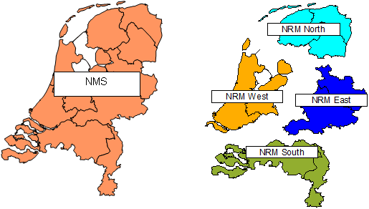

Figure 1: Study areas of the National Model System and Netherlands Regional Models

At Figure 1 are the National Model System (consists of four regional models together) and the four Netherlands Regional Models (depicted with different colors) are given.

The actualization of the models is necessary and highly recommended and has the following cycle: a) the **actualization of the model input** (road networks, socio-demographic information, etc.) every year; b) building the **new base year** for the models (every four years).

1. **NATIONAL MODEL SYSTEM AND NETHERLANDS REGIOANAL MODELS 2016**
   1. Properties And Model Principles

The model system can be classified as a **multi-modal strategic** traffic and transportation model. The model knows **six transport modes**, namely car driver, car passenger, truck, train, BTU (Bus, Tram, and Underground), bicycle and the pedestrian (walking) transport mode. The traffic is modeled in **three time periods**: morning peak, evening peak, and the remainder of the day. Five main home-based **travel purposes** are modelled: home-work, home-business, home education, home shopping, home-other. Additional non-home travel purposes modelled are home-business, work–education, work-other, child-education, child-shopping and child-other.

It should be noted that an **average workday** is modelled, which includes vacation periods, but excludes the weekends and national holydays. The model is **tour-based** meaning that the frequency of travelling is made on basis of tours (and not on basis of trips). For every tour the primary travel purpose and the primary transport mode is determined.

The NMS and NRM models use huge amount of input data. The NRM input comprises, among others: the zone system, the road network system, de socio-economic data, the given policy principles for e.g. fuel costs, parking prices, etc. For more information about the input data we refer to the previous papers about the NMS and NRM models.



Figure 2: the core processes in determining the Forecast matrices using growth model

The NMS and NRM are so called *marginal* or *pivot point* models. That means that the traffic forecast is obtained by multiplying the calibrated base year matrices with the calculated growth factors using discrete choice models. The NMS and NRM produces *long-term traffic forecasts* based on economy development scenario’s in the Netherlands traffic and transport system. Currently forecasts are made for 2030, 2040. The forecast are made based on the given long-term scenarios published by the Dutch planning agencies.

The NMS and NRM are complex strategic models consisting of many components. The most important components are:

1. **Base matrices** that represent the mobility in the base year, which is currently 2010; Base year data (observed) and traffic counts (empirical) are the basis for the process where the ‘’car driver’’ and ‘’freight’’ base matrices are calibrated. The base year matrices for car driver and truck are built in the so called BASMAT process.
2. **Regional Freight Model (RFM),** the model for producing the input for the building of freight base matrices in the BASMAT process as well as the freight forecast matrices; The freight base matrices are calibrated with traffic counts. The freight forecast is based on the calculating of the growth factors with respect to the base year.
3. **Growth model (GM),** the model for generating the forecast matrices based on the pivot point method. The GM uses base year data (observed) and forecast year data (prognoses), and a scenario to calculate growth factors with which the base matrices are multiplied to determine forecast matrices.

The growth model itself consists of a suit of sub models, but the core is formed by the **demand model** that, based on input data for a year and a scenario, produces a *synthetic demand matrix*. It is named synthetics because it is a model result rather than an estimation result based on observations. The synthetic demand matrices for both the base year and the forecast year are then used to determine **growth factors**. The growth factors are multiplied with the base matrix to determine the forecast matrices, see Figure 2.

Figure 2 does not show the full complexity of the model system. The influence of congestion is not shown. Taking account of that effect leads to an iterative process in which the congestion on the road network interacts with the demand generated by the demand model for car travel.

* 1. Application of the Netherlands Regional Model

As stated before, the NMS and NRM models are used for the evaluation of strategic policy plans and regional and national road scheme investments. The effects of different policy measures, e.g. building a new highway, or adding extra capacity to the existing highways, improvements in the train services etc. can be *modelled,* *analysed, tested and evaluated* using the model. The results of the model are further used for the analysis and calculation of the *effects of noise and air pollution* of the particular policy measure and infrastructure investment. The *cost-benefit analysis* also uses the model results to make policy decisions about the efficiency of different policy measures. Furthermore, the model data are used as input data in the other local traffic models (e.g. dynamic models).

NRM models can be used as a traffic and transportation information source in the region. Parts of the model can also be used for further development of other local traffic and transportation models for e.g. for the local models of the municipalities.



Figure 3: Typical phases in a planning studies

In the exploratory phase the existence of future traffic and transportation problems are first identified and potential solutions are outlined. In this phase the use of models is generally not necessary. The decision making about the promising solutions is mostly based on the expert judgment. The result of this phase is set of promising alternatives. Furthermore, a preferred alternative is chosen on the basis of the model results. The use of the NMS or relevant NRM model is mandatory in the second phase of the explanatory study (see Figure 3). In the planning phase the models are used for more elaborate calculation of the different variants of the chosen alternative.

It should be noted that in order to improve the quality assurance of the model Rijkswaterstaat developed a protocol. It is compulsory to abide by this protocol during every application of the NRM models (in different planning phases in the project).

1. **BUILDING THE BASE YEAR 2014**
   1. Project planning and project organization

The building the new base year of strategic models covering the whole country is a very complex process in terms of project organization, collaboration of different stakeholders, accommodation of opposite interests of involved parties, etc. In such a project a high level of collaboration of different stakeholders is required. Looking at the building the new base year from a single perspective does not seem enough because many actors are involved.

The whole process takes about two years and consists of different phases:

* *Phase 1*: **Collection an preparation of the input data** for the calibration
  + the car networks for year 2014,
  + set of the traffic counts,
  + the freight car matrices,
  + the BTM (bus, tram and Underground) data,
  + the social economic data, etc;
* *Phase 2*: **Calibration of the base year** consists of several parts
  + the preparation of calibration (technical setup)
  + the test calibration
  + the definitive (final) calibration;
  + the harmonization step for all models;

the results of this phase are the base matrices for car and the base matrices for freight

* *Phase 3*: **Assessment of the quality** of the base year and the necessary improvements
* *Phase 4:* Building the **traffic forecast** with the new base year
  1. **Challenges to the calibration**
     1. **A-priori matrices**

The project deals with the following decision point: the choice of input matrices for the preparation of the base year data. These so-called a *priori matrices* describe the estimated travel (car and freight) based on the various research data. During the final calibration, these theoretical data are aligned with the observed number of vehicles on the roads in 2014. This process forms the core of the base year and updating the resulting matrix form the basic for a realistic mobility image of year 2014 and future situations. There are different possibilities.

When choosing one of the options, the quality of a priori matrices have an important role. The quality is made transparent by a quantitative assessment with respect to the travel survey - Research of trips in the Netherlands (OViN) for year 2014.

The matrices are finally estimated based the Growth Model version in which the significant model innovation (integral modelling of rail traffic) is implemented and also this version will be used for the forecasts at the end of 2016. This option is found to be the most consistent way to derive the apriori matrices.

* + 1. **Other improvements**

The most significant calibration improvements are: improvement of modeling of patterns of ‘’wish demand’’ and the traffic networks in the big cities, harmonization of the capacities of the traffic networks according to the recent highway capacity manual, significant improvement of the quality of the public transport data. With regard to the improvement of the model techniques, the calibration process of the base year matrices is adapted (using traffic accounts as well as screen line information), better controlled and documented to assure quality. Further improvements have been made in the modeling of traffic traveling abroad (besides Schiphol airport all other significant regional airports are now included in the model).

1. **CALIBRATION PROCES**

In the calibration process the new origin-destination (OD) matrices (for car passenger and freight) are derived for the base year 2014. On the basis of these base matrices and using the *growth factors* the future matrices can be derived. It should be noted that the quality of the base matrices is essential for the plausibility of the final traffic forecasts of the NRM and NMS.

5.1. Fases in the calibration process

Figure 4 summarizes the main parts of the calibration process and the consistency between the processes. The calibration process is similar to the dotted rectangle  
at Figure 4 and consists of two phases: a) the calibration of the matrices for car driver and b) the calibration of the freight matrices. In Phase 2 these two processes overlap each other.

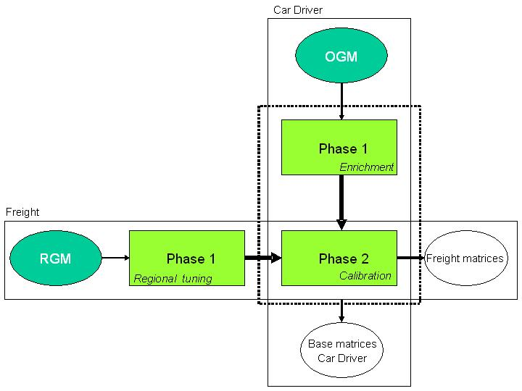

Figure 4: The framework of the calibration process of the base matrices

5.1.1. Fhase 1: Car Driver: Enrichment of the a-priori matrices

The enrichment of the a-priori matrices on the basis of the empirical information can be done in a number of ways:

a) Calibration on counts at the border crossings;

b) Scaling of the a priori matrices per time-of-day periods;

c) Trip length distributions for the study area, the provinces, the regions and the four major cities (Amsterdam, The Hague, Rotterdam and Utrecht);

d) Trip length distributions from the licence plates travel surveys.

The use of the previous stated information is optional in this phase of the calibration and is determined based of the quality of the a priori matrices.

Phase 1 is repeated for each travel motif and in the first instance, only for the whole day matrices. If it is found that the result is insufficient, the cause need to be identified and, if necessary, the entry for Phase 1 corrected. If enriched (the whole day) matrices are finally accepted then the time-of-day matrices are derived and further tested. Depending on the outcomes, it is possible that one or more time-of-day/motif matrices combinations need to be estimated separately.

For the enrichment of the freight the regional tuning of the a-priori matrix (using free flow assignment and screen line information) is used.

5.2 Phase 2: Simultaneous car and freight calibration

In Phase 2 of the calibration process the simultaneous calibration takes place. Simultaneous in this case means that car and freight traffic is simultaneously assign to the traffic network (taking into account mutual interactions) using the assignment traffic model QBLOK. Then the both modes are calibrated separately against their individual target values.

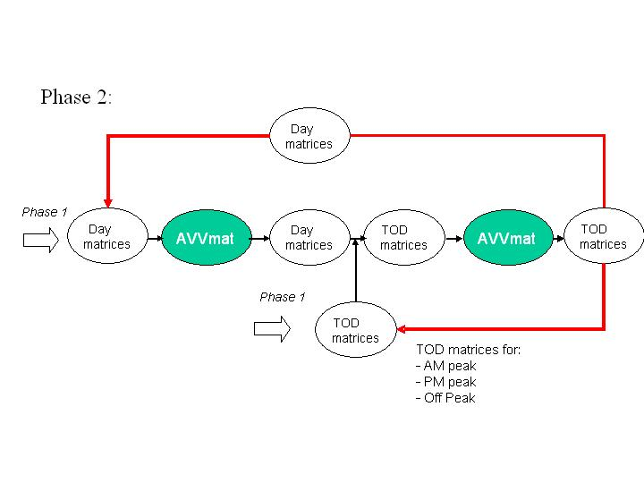

Figure 5: Simultaneous calibration (car and freight)

The process of calibration is an incremental and iterative process*.*

1. *Incremental* (step by step) because the calibration process uses individual traffic counts (of e.g. screenline counts) as an *initial set* in the beginning of the calibration process, and later *further expansion* of the set of counts is applied.
2. *Iterative* because on the one hand, the route choice is determined again after each iteration and the input matrices are replaced in the next iteration of the calibration process (with the calibrated matrices from the previous iteration). Iterative is also because first the whole day matrices is calibrated and then the three day periods (time-of-day matrices).

The targets in the calibration are different for cars and for freight matrices and also differ for the car for the time-of-day matrices. The empirical data from phase 1 (one part of them) are also included in Phase 2. For the car whole day matrices beside the counts also the *productions and attractions* and the *trip length distributions* are included. Since in the quality assessment tests also the licence plates travel survey can be used, it is possible to extract these information (from the licence plates travel surveys) and use it in this phase of the calibration process.

5.3. Monitoring the Calibration and Quality Process

The development of strategic models covering the whole country is a very complex undertaking in terms of project organization, collaboration of different stakeholders, accommodation of opposite interests of involved parties, etc. In such a project the high level of collaboration of different stakeholders is needed. Additionally, a quality control of the model as whole (as well as the parts of the model) is improved to ensure that every improvement or update of the model and information is reliable.

In the monitoring of the calibration and the quality improvement process the following questions were answered:

* What is the match between the assignment and the traffic counts?
* Visual check of the geographical match between counts and assignment
* Visual check of congestion locations and congestion queues in the assignment
* How well is the structure of the a-priori matrices maintained (aggregated OD tables and scatter plots of the total matrix)?
* Is the day matrix still symmetrical?
* What is the % of null-cells in the matrix?
* Trip Length Distribution per Province in each iteration compared to TLD form National Travel Survey

1. **IMPROVEMENTS IN THE CALIBRATION PROCES**
   1. **Using better input**

The main input that was improved has been the count data. Previously the count data collected was taken from many different available sources. The source where different in measurement period, measurement method, measurement accuracy and in many other aspects. The quality was similarly diverse and it was a huge under­taking to arrive a consistent dataset.

For base year 2014 the bulk of the data has been drawn from the system called INWEVA. This system creates a consistent count dataset with the purpose to make consistent calculations on environmental indicators.

With INWEVA the national road system is covered. For provincial roads and local roads additional count data is obtained from our regional partners. Unlike last time, for 2014 count data was collected for specific locations for which count data was available. Overall the collection of count data was much more coordinated and such has taken less effort. A few new problem have risen, but overall the new approach has been an improvement.

* 1. **Improvements in the process**

The process for the actualisation of base year 2014 has been adapted in a principal way. Previously the actualisation consisted of a large number of separate steps (subprojects) that were commissioned to individual consultants. Rijkswaterstaat itself coordinated the project as a whole and would control all inputs and outputs between the individual steps. For base year 2014 a big portion of the entire process has now been commissioned to a single consortium. The consortium now coordinates and has the responsibility for the part of the process commissioned to it. Due to this new setup the process is improved within the project.

Although the project is ongoing outsourcing a larger part of the process is working out as expected. Rijkswaterstaat can focus on more content instead of process.

* 1. **Improvements in the preparation**

During the calibration of the new base year the regional partners were informed regularly and there help was called for to analyse results and the solved local calibration problems. The regional partners were also heavily involved in the preparation process. They were asked to deliver additional count data, to help check and improve the network, the deliver line information for public transport, to select the most important congestion locations to be modelled (in relation to infrastructure improvements that are planned or being planned) and the selection of locations on which the validity of the assignment will be tested.

* 1. **Better monitoring**

During the calibration the progress was monitored by the Rijkswaterstaat and the regional partners. To facilitate this a webtool was created via which all those involved could inspect the results, make comments and during the validation process make corrections. The webtool was received as a significant improvement to the process. It was used heavily, overall lead to a better involvement of regional partners and resulted in much better networks and higher quality of data in general.

1. **PRELIMINARY RESULTS**

The calibration has not been completed yet but the preliminary results look promising. In comparison with the previous calibration for base year 2010 currently similar or better results are obtained. One of the measures used to indicted the difference between the count data and the modelled data (so called T-value). In the following two plots (Figure 6 and 7) the T-value for the measurement location is shown for both the apriori matrix and the resulting base matrix after calibration. Green means that the T-value is within an acceptable range, red means that it is outside this range.

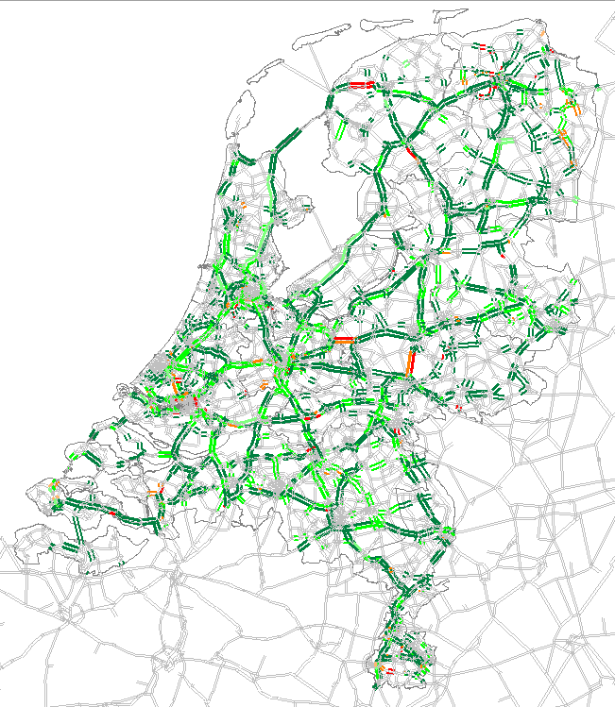

Figure 6: T-values for 24 hours workday in the apriori matrix (left) and the base matrix (right)

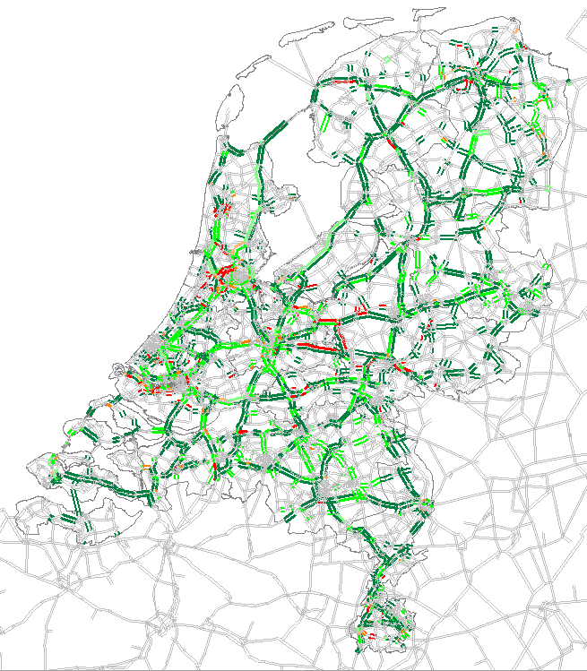  
Figure 7: T-values for the morning rush hour on a workday in the apriori matrix (left) and the base matrix (right)

1. **SUMMARY AND CONCLUSIONS**

The focus of this paper is on the latest developments in **calibration of the new base year** for the model, the generation and improvement of the input data for calibration corresponding to this new base year as well as quality assessment of the models. Next to renewed efforts in keeping the models up-to-date (the time between the base year and the moment the models are available is reduced) there have also been a number of other model improvements.

The most significant calibration improvements are: improvement of modeling of patterns of ‘’wish demand’’ and the traffic networks in the big cities, harmonization of the capacities of the traffic networks according to the recent highway capacity manual, significant improvement of the quality of the public transport data. With regard to the improvement of the model techniques, the calibration process of the base year matrices is adapted (using traffic accounts as well as screen line information), better controlled and documented to assure quality. Further improvements have been made in the modeling of traffic traveling abroad (besides Schiphol airport all other significant regional airports are now included in the model).

The calibration has not been completed yet but the preliminary results look promising. In comparison with the previous calibration for base year 2010 currently similar or better results are obtained. One of the measures used to indicted the difference between the count data and the modelled data Is the so called T-value.