European Transport Conference 2013

ADDRESSING THE LINKAGE FROM AIR TRANSPORT DEVELOPMENT TO GENERAL SUSTAINABILITY GOALS

Alexandra Leipold, Michael Hepting, Petra Kokus
German Aerospace Center (DLR)
Institute of Air Transport and Airport Research

ABSTRACT

Within the last decades the air transport sector grew considerably with all its positive as well as negative effects on the three pillars of sustainability: economy, environment and social issues. Consequently, the striving for economic growth and welfare which is driven by aviation has to find balance against the public interest in an efficient, safe and affordable air transport system by minimising the environmental impacts at the same time. Addressing this problem, the claim of this paper is to present a consistent scientific approach that is the foundation to (1) describe developments in air transport with regard to its economic, environmental and social impacts in a structural way, (2) monitor changes over time and (3) assess the overall development in the air transport system in the context of general sustainability. Based on this research framework the outcome of this paper is first to introduce a harmonised system of indicators that is capable of showing general trends in air transport in linkage to the three dimensions of sustainability on a macroscopic level. In a second step, this indicator system will be extended to conduct an analysis of long-term trends over 20 years to identify system-immanent trends and interdependencies between the selected indicators. In a last step, the analysed air transport development will then be compared with general sustainability goals from the field of politics and the aviation industry in order to assess the observed trends. Conclusions for the improvement of the performance of air transport in regard to sustainability will be drawn from this work.

Addressing the linkage from air transport development to general sustainability goals

- Introduction

Within the last two decades, the global passenger volume in air traffic – measured in revenue passenger kilometres – grew annually by 5.0% on average (ICAO 2012). From a sustainability perspective this development must be regarded critically as this tendency means positive as well as negative effects at the same time with regard to the three pillars of sustainability: economy, environment and social issues.

The observed growth of the aviation sector has e.g. led to a considerable increase in social welfare over the last decades, especially in terms of global GDP development, as air transport is one important driver for the global economy. In addition, global GDP growth also stimulates air transport growth in turn and generates employment (Oxford Economics 2011). Meanwhile, from an environmental point of view the rising number of flights on global scale means at the same time rising GHG emissions – especially CO₂ emissions – (Lee, D.S. et al 2010) and on local scale a rising noise exposure for the population in airport surroundings. Finally, conflicting developments can also be identified for the social dimension of sustainability. Due to economic considerations, the access to the air transport system and the affordability to fly is not evenly spatially spread all over the world. Affordable ticket prices in relation with suitable connectivity options and the highest achievable safety standards are nevertheless important as they contribute to a higher number of people to profit from the global air transport network (ICAO 2012).

Addressing this situation, a consistent scientific approach is needed in order to (1) identify and describe these aspects in a structural way, (2) monitor changes over time and (3) assess the overall development in the air transport system in the context of sustainability in general.

Based on this research framework, the purpose of this paper is first to introduce a harmonised system of indicators that is capable of showing general development trends in global air transport with regard to their economic, environmental and social impacts. To realise this system, data identification and processing had been undertaken in consideration of air transport system internal sources as well as framework data with information about the overall global population and economic development. In a second step, the indicators then allowed a detailed monitoring and description of changes over a time span of more than 20 years. Thus, even long-term and system-immanent trends and the interdependencies between different indicators in the selected set could be identified. As third step a direct linkage to sustainability goals was needed in order to classify and evaluate the aviation development in the context of sustainable development. For this purpose an extensive investigation of existing sustainability goals from the field of politics (e.g. UN General Assembly Resolution: The future we want – Our common vision) and the aviation industry (e.g. IATA Vision 2050) was carried out. All those initiatives were regarded critically in terms of their expressiveness, relevance and transferability with regard to the air transport sector.

As first result of this work the different indicators could be assessed against the proposed strategies within the chosen sustainability goals. This allowed discussing the already identified development trends in the field of air transport and sustainability critically. Furthermore, this analysis could serve as a basis for suggesting concrete improvements for air transport activities towards the desired more sustainable pathway for the future. In addition, the detailed analysis allowed also testing the practicability of existing sustainability goals with regard to one specific sector and to address the problem of contradictions between different sustainability goals and negative trade-offs in the overall indicator development. With this approach the conducted work is a first contribution for further discussions about responsible actors in the field of air transport and sustainability and the derivation of concrete steps for further improvements within their responsibility area.

Summing up this outcome, the expected conclusions can be regarded as being of high importance for the aviation research community as well as for stakeholders from air transport industry, regulators and politics due to the established linkage between policy-setting in the field of sustainability and the comparison to real conditions in the air transport sector. The elaborated indicator system which is one basis of this paper had for this purpose already been made publicly available in the scope of the MONITOR project (www.airtransport-monitor.eu) and is foreseen to be updated regularly as an instrument that allows a permanent monitoring of air transport sustainability performance.

- Monitoring of the air transport system development by usage of an indicator system

  - Elaboration and presentation of a harmonised set of indicators

The general use of indicators is an efficient mean to provide short and concentrated information on a special topic. In regard of the analysis of the air transport sector indicators can in this context fulfil the function to describe and evaluate the air transport system development and the resulting ecological, economic and social impact under the postulate of sustainability. Furthermore, another advantage is that a suitable indicator set can be adapted to different geographical and temporal levels according to specified investigation needs. Due to the bundling function of indicators in reference to the air transport system’s individual components, its main drivers and actors, indicators may also overtake the function of an early warning system as they facilitate the identification and observation of trends.

The preliminary set of indicators which forms the basis for the further discussion in relation to this paper, was developed within the MONITOR project (Monitoring System of the Development of Global Aviation). The project MONITOR was funded in the 7th Framework Programme of the European Union and served the purpose to set up a permanent monitoring system for analysing the global aviation development. According to the following figure this system was based on three pillars.

Figure 1: Overview of the MONITOR monitoring system

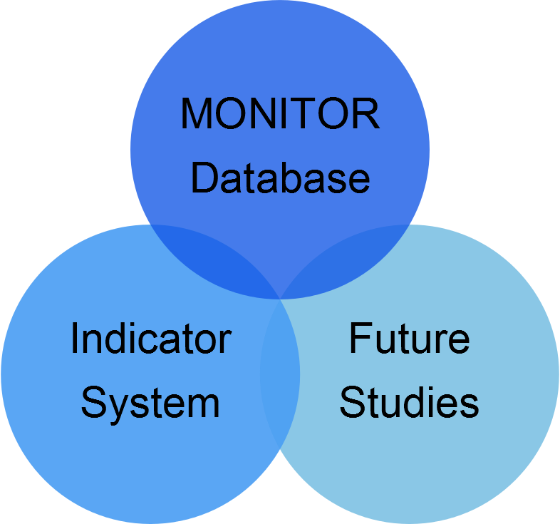

Besides of the mentioned database and the future studies, indicators formed from the beginning on an essential part of the planned monitoring system to cover the manifold facets of the air transport system, its drivers and limitations and to evaluate if the real air transport development with its diverse components is in line with set policies. Starting from this point, a first set of indicators was developed as outcome of a strategic process that is illustrated in the following figure and will briefly be described in the following.

Figure 2: Process of indicator creation

1. Evaluation and commitment with regard
to indicator scheme
2. Questions to be monitored
3. Identification of
indicator interrelations
6. First set of indicators
5. Qualitative discussion of the air transport development
7. Update and presentation concept
Significance of the
indicator
Data harmonization needs
Accountability
4. Check of data availability and selection of indicators
Geographic and temporal coverage
Work sharing and communication

Referring to Figure 2, the first working step included a decision under which perspective and to what extent an indicator scheme could be used as an approach for monitoring the air transport development over the long-term. Under consideration of the recommendations of relevant air transport stakeholders from the field of politics, industry and science a first suggestion for a corresponding indicator concept was elaborated. For this concept it was agreed to consider the actors and dimensions which are given in the following figure. Furthermore, it was distinguished between Performance Indicators (PIs) which have the function to evaluate the development of air transport with regard to its basic purpose which means the provision of fast, reliable and manifold transport opportunities and Sustainable Development Indicators (SDIs). The latter go beyond the scope of PIs by concentrating on the interrelation between air transport system developments in relation to external developments with high impacts like population or economic growth. Thus, SDIs allow to discuss the air transport development in relation to the three pillars of sustainability.

Figure 3: Overview of the MONITOR indicator concept

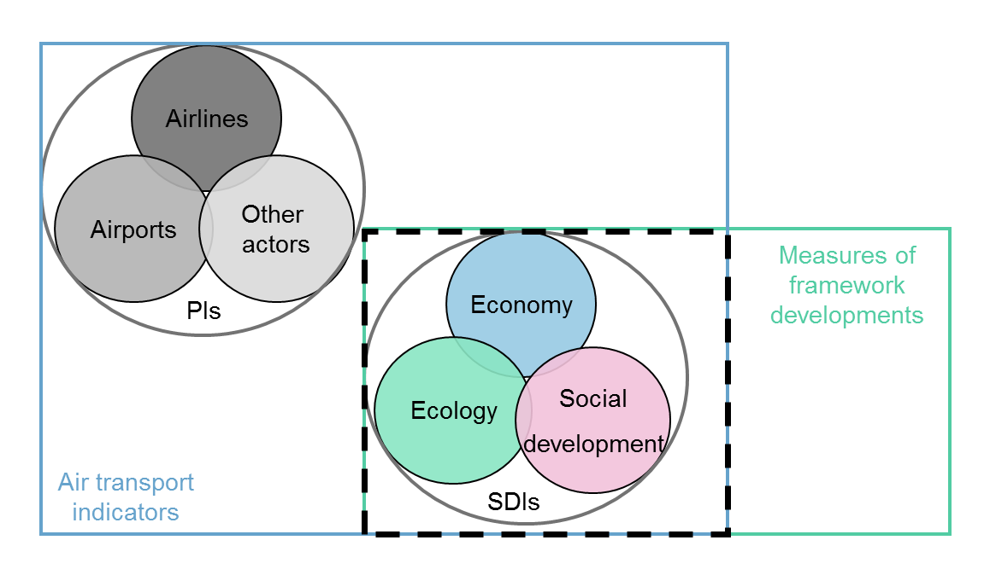

Based on step 1, important questions were formulated in the next step to determine which questions should be answered by the planned indicators and which indicators contribute the most to on-going research priorities. Starting from this, step 3 discussed possible indicator interrelations which should be addressed in the further overall analysis in order to provide a holistic view on the air transport system and to make sure that the relation between its individual components is addressed.

The main work effort consisted, however, of step 4 which dealt with the final selection of suitable indicators which fulfil the resulting requirements of step 1-3. In addition, the indicators to be chosen had to be significant and accountable. Detailed communication among the project team was important at this point to clarify data availability and to discuss and realise harmonisation needs of the chosen data. Accordingly, the raw statistics and information was compared, merged and harmonised to satisfy the requirements concerning the temporal and geographic coverage of the indicators.

Taking into account these previous working steps, step 5 mainly dealt with the qualitative assessment of the harmonised data and the discussion of first findings. Within step 6 a first set of indicators was then built on this basis which will briefly be introduced in the next section. Finally, a presentation concept for the indicators on the MONITOR website was additionally elaborated. The results of this work are publicly available and regularly updated (cf. www.airtransport-monitor.eu/indicators).

  - Outcome of the indicator monitoring concept for air transport development

Based on the work described in section 2.1, the first set of indicators which was elaborated during the MONITOR project and which represents the core of the intended concept for a continuous monitoring of the air transport development, can be distinguished according to different categories. First, PIs and SDIs can be differentiated. Second, the PIs are furthermore differentiated by the regarded actors, i.e. airlines and airports. Third, the elaborated indicator set can be classified according to its geographic coverage which mainly deals with global or world regional developments on aggregated scale. Finally, all indicators are designed to reflect more or less long-term developments with a 20-years time horizon what facilitates the recognition and analysis of trends.

The thus created set of indicators contains within its current state 5 categories of PIs including 27 single indicators and the three categories of SDIs with 16 single indicators. An overview of this set is provided by the following figure.

Figure 4: MONITOR Performance and Sustainable Development Indicators

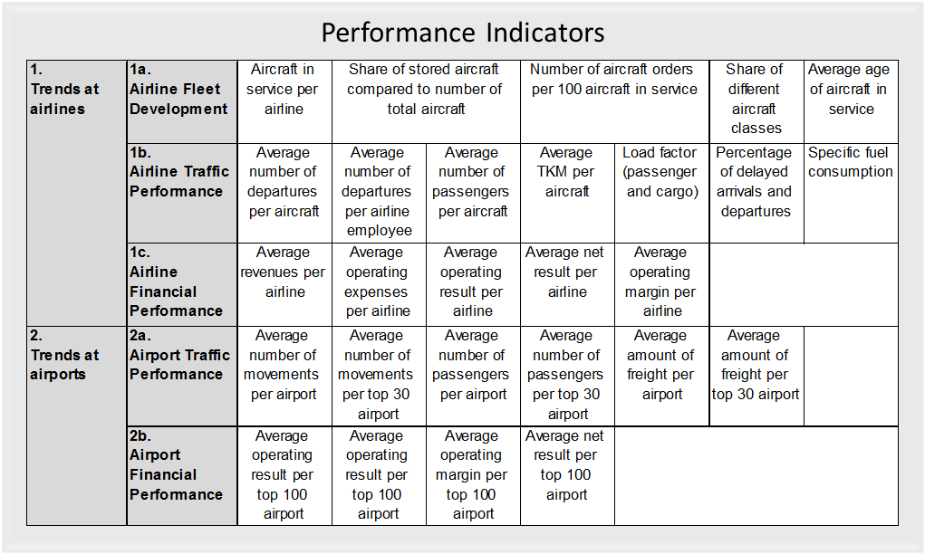

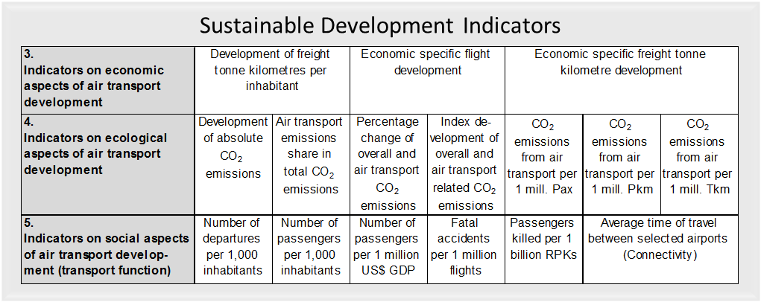

- Sustainable and strategic development goals

  - Sustainable development goals

In order to evaluate the aviation development expressed by the indicators in the context of the requirements for a sustainable development a direct linkage to existing development goals is needed. For this purpose, goals from the field of politics which we classify as sustainable development goals due to their legitimate and recognized status were analysed. In addition, strategic development goals from the aviation industry which may also deal with sustainability topics were regarded to complete the view. However, as the focus of this paper is on sustainable development goals the latter will only be discussed shortly in section 3.2.

Placing the emphasis on existing sustainable development goals from the field of politics, an analysis shows that only a minority of actors have set up clear and aggregated sustainable development goals. Often these goals are focused on the transport sector in general. Concrete specifications for the aviation sector are even harder to find. Therefore, the main guideline for the further analysis of the air transport development in the light of sustainability will be the final resolution of the Rio+20 conference (UN 2012). This document includes at least two sections about sustainable transport and highlights the special function of transport to strengthen economic development and to provide mobility opportunities by mentioning:

(1) The importance of the efficient movement of people and goods
(2) The relevance of access to environmentally sound, safe and affordable transportation as a means to improve social equity, health, resilience of cities, urban-rural linkages and productivity of rural areas
(3) Road safety as part of the UN’s efforts to achieve a sustainable development
(4) Support for the development of sustainable transport systems, including energy-efficient multimodal transport systems, notably public mass transportation systems, clean fuels and vehicles, as well as improved transportation systems in rural areas
(5) The need to promote an integrated approach to policymaking at the national, regional and local levels
(6) The development needs of landlocked and transit developing countries

Taking all these statements into account, all points with exception of no. 3 are important and relevant for the air transport sector. They will therefore be considered in the detailed analysis of the air transport indicators in relation to section 4.

Another source for sustainable development goals has a minor coverage than the UN publication but should nevertheless be mentioned here for completing the point of discussion. The “Vision 2050”, published by the World Business Council for Sustainable Development (WBCSD 2010), lists two goals for the aviation sector development:

(1) Decrease of GHG-intensity of aviation by 50% up to 2050
(2) Increase of sustainable biofuel use in aviation by 30% up to 2030

In regard of these goals it may also be of interest how the air transport sector might develop in the long-term.

  - Strategic development goals

To complete the view on existing goals for the air transport sector the strategic goals of the following actors were investigated: ICAO, IATA and ACARE. As the following table summarises, the main priorities of these actors are very similar with regard to their content. The only difference is that the ACARE goals concentrate mainly on the air transport development in Europe due to a strategic point of view.

Table 1: Strategic development goals of IATA, ICAO and ACARE

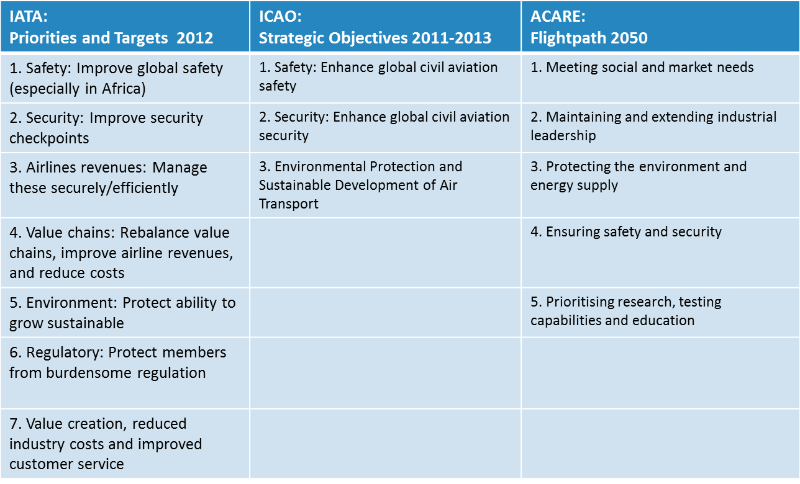

- Assessment of the developments in air transport in the context of sustainability

  - Discussion of the identified development trends

Taking into account the chosen sustainable development goals of the UN in linkage to observable air transport trends expressed by the indicator concept, an analysis of the air transport development in the context of sustainability can be realised. For this purpose suitable indicators from the MONITOR indicator set were chosen on the premise that they allow to show if a trend develops in line with the identified goals or against it. In order to facilitate comparisons these indicators were indexed according to the reference year 1990 and presented in a single graph.

Figure 5: Selected air transport indicators and past development of the air transport system

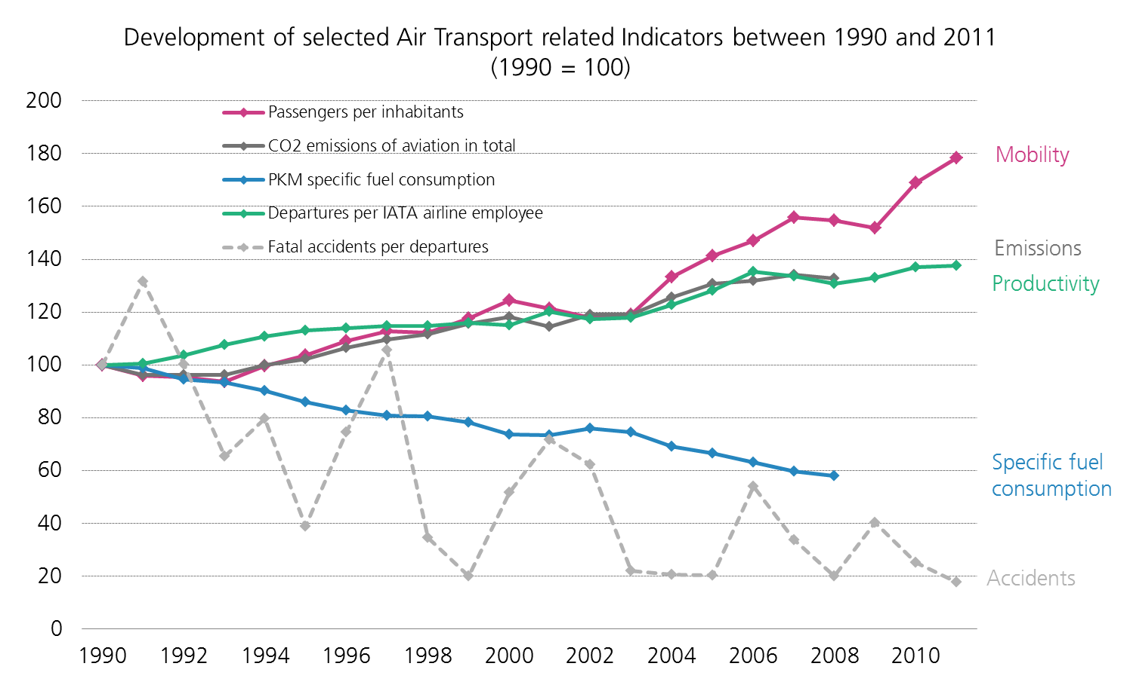

The indicators given above deal all with different elements of the air transport system and partly external framework developments. Thus, they are useful to to highlight different developments in linkage to the chosen sustainability goals. While the curve shapes of fuel consumption and productivity are referring to air transport system internal trends and can be classified as PIs according to the MONITOR indicator scheme, the curve shapes of emissions, accidents and moblility cover also external trends and can therefore be allocated to the SDIs.

Analysing the different trends in more detail, the analysis shows that many of the given indicators are in line with the identified sustainability goals extracted from the UN final resolution of the Rio+20 conference. The indicator for indexed productivity which is measured in departures of all IATA airlines per IATA airline employee shows for example a rising trend curve. In concrete the productivity in the airline sector rose between the years 1990 and 2011 by about 37%. This indicates that obviously less personnel was needed over time for realising the same amount of traffic. Although the effects of outsourcing or the tendency for more shorter flights, which can be operated in less time due to the rise of low cost carriers, might not exacly be considered here, the observed trend can in general be classified as a positive one. As a higher working productivity normally leads to cost savings these could theoretically be overwhelmed to passengers. Although this may not be done in practice in any case, in general this means that the complete transport system becomes more efficient and affordable and this is in line with the UN goals no. 1 and 2.

Similar conclusions can also be drawn for the indicator on the specific fuel consumption which was built on the basis of data extracted from the Emissions Database for Global Atmospheric Research (EDGAR). Between the years 1990 and 2008 the specific fuel consumption decreased by more than 40%. As this indicator expresses the technological development of the global aircraft fleet, this tendency has also to be regarded as a positive one in the light of the UN goal no. 4. However, the CO₂ emissions resulting from aviation, which were also extracted from EDGAR, grew during the same time nearly in the same dimension. Obviously, the technological improvement could therefore not cope with the increased traffic growth in aviation and this represents a clearly undesired trend in comparison to the UN sustainable development priorities no. 2 and 4.

Switching to the SDI on safety, expressed by fatal accidents per 1 million departures, which was derived from IATA statistics, another high-priority target of the UN is adressed. Compared to the UN priority on safety, which is described in goal no. 2, the development which is shown by the indicator is clearly in line with the desired perspective. Although safety is normally a highly volatile measure due to the unpredictability of emergencies the observed tendency is a positive one. Between 1990 and 2011 the number of fatal accidents per 1 million departures decreased by approximately 80%. This expresses an obvious improvement.

The last indicator in the shown indicator set deals with mobility, which is in the given example described by the measured number of passengers per 1,000 inhabitants. Thus, the level of air transport usage can be compared to the global population development and it can be assessed which share of the global population participates in the air transport system. Although the figures do not allow to draw conclusions on social justice by questionning who exactly has access to the air transport system, the curve shape allows to draw some general conclusions. In concrete, the mobility curve shows the clearest upward trend within the selcetion of all indicators by illustrating an increase of nearly 75% over a more than 20year time span. Thus, in general it can be concluded that this trend corresponds to the priorities the UN has set with goal no. 1, 2, and 4.

To sum up the findings, the following table summarises again the main results. The chosen goals of the UN are merged with the indicators that tell something about goal efficiency. Rising arrows show in this case if we have an increasing tendency over the years under investigation, while descending arrows indicate a downward tendency. Positive developments are furthermore expressed by green arrows. Negative developments are highlighted by red arrows.

Table 2: Air transport development tendencies of the last 20 years in regard of the UN Resolution A/RES/66/288

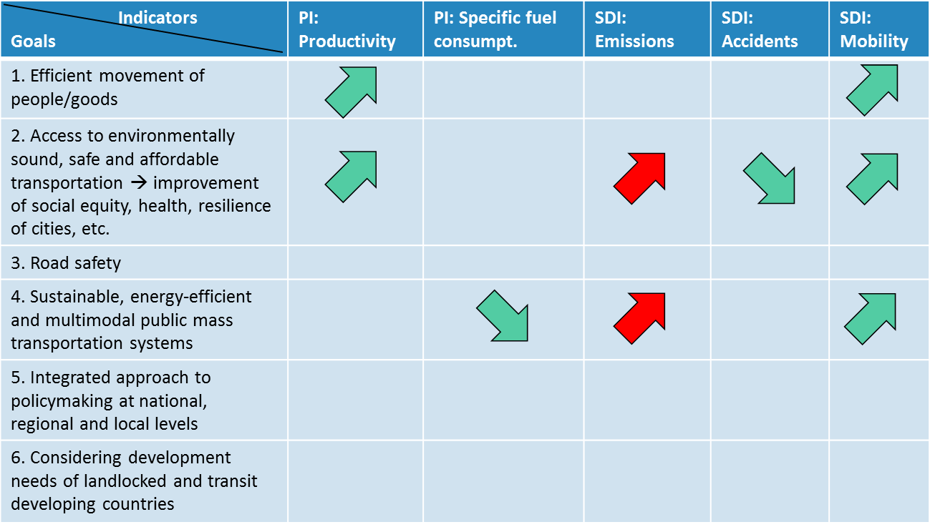

  - Linkage between policy-setting for sustainability and real conditions of air transport

The analysis of section 4.1 has shown that many of the observed trends are in line with the discussed UN goals. The only exception is the development of the overall CO₂ emissions resulting from aviation that climbed by about 37% over the last 20 years. This tendency marks therefore an area on which attention should be put on by politics as well as by the aviation industry as emissions driven climate change represents a severe problem for the future global development.

With regard to this problem the findings from the research conducted in relation to this paper show that especially in reference to the negative environmental impact from aviation activities but also with regard to general goals for the future aviation development a balanced and harmonised approach on global scale is missing. Especially the drivers for aviation, the involved actors as well as the resulting effects are manifold and complex as the following figure indicates.

Figure 6: Actors and correlations of the air transport system

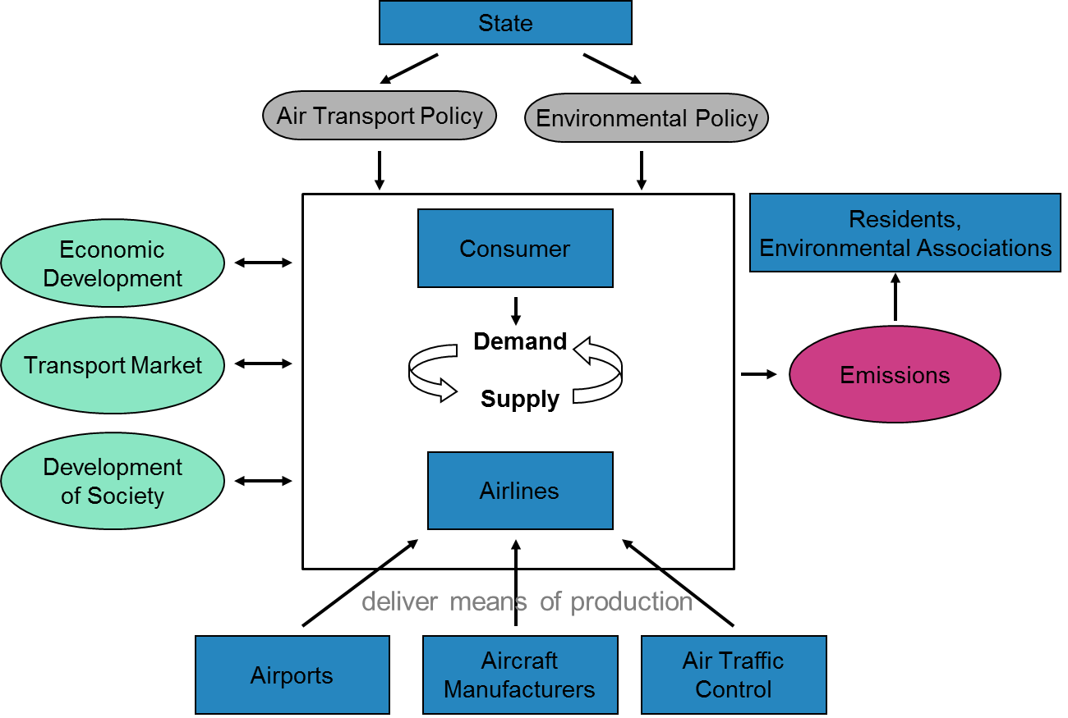

Against, this background it is furthermore important to establish up a continuous dialogue between all involved actors and to adapt suggestions for binding goals and priorities to each other. With regard to the existing goal frameworks which were analysed in preparation of this paper, some existing goals had rather shown partly target conflicts, e.g. when ACARE or the UN stress the need to satisfy market needs concerning transport demand and the need to protect the environment at the same time. This means that aviation growth is desired on the one hand, while environmental protection is demanded at the same time without addressing possible resulting contradictions in respect of these two development perspectives.

In this respect a first approach for improvement could consist of putting the environmental domain continuously on top of the agenda and planning and thinking for the long-term. Furthermore, not only “headlines” or strongly aggregated goals should be presented in the existing goal frameworks as it is today partly the case. Instead, the needed requirements to reach the agreed goals as well as resulting advantages but also disadvantages for some actors and target conflicts should clearly be discussed and published. This allows a dialogue and stimulates transparency. In addition, the linkage to other transport modes and the focus on on-going developments cannot be underestimated if a common, balanced and successful framework of goals for the future aviation development should be established.

- Conclusion

The aim of this paper was to investigate the past and current air transport development in linkage to general sustainability goals. For this purpose an indicator set was built and compared to identified goals from politics and the aviation industry. In this context the UN Resolution A/RES/66/288 was regarded as most promising to be considered for a further in-depth analysis in order to discuss the main trends in the global air transport system of the last 20 years and to evaluate if they are in line with the desired priorities for the future. With the exception of the CO₂ emissions it could be found that this requirement is fulfilled. However, the co-existence of different goals for the air transport and the transport sector, the partly missing precision in the formulation of these goals and the involvement of manifold actors make it difficult to determine a promising development vision for the future. Therefore, first suggestions were made how a common and efficient framework of goals for the future aviation development could be established.

BIBLIOGRAPHY

ACARE (2012) Flightpath 2050 – Europe’s Vision for Aviation. URL: http://www.acare4europe.org/sites/acare4europe.org/files/document/Flightpath2050_Final.pdf, 27.08.2013.
IATA (2012) IATA’s Industry Priorities and Targets. URL: http://www.iata.org/about/Pages/priorities.aspx, 27.08.2013.
ICAO (2013) ICAO Strategic Objectives 2011-2013. URL: http://www.icao.int/about-icao/Pages/Strategic-Objectives.aspx, 27.08.2013.
ICAO (2012) Working Paper - Worldwide Air Transport Conference (ATCONF): Sustainability and Economic Development of Air Transport, Montreal.
Lee, D.S. et al (2010) Transport Impacts on Atmosphere and Climate: Aviation. In: Atmospheric Environment (44), pp. 4678–4734.
Oxford Economics (2011) Benefits of Aviation.
UN General Assembly (2012) Resolution A/RES/66/288 “The Future we want – Our common vision”, New York.
WBCSD (2010) Vision 2050.

