Explaining the rapid diffusion of battery electric vehicles in Norway
Erik Figenbaum
Marika Kolbenstvedt,
Institute of Transport Economics, Oslo, Norway.

Introduction
The purpose of this paper is to investigate how Battery Electric Vehicles (BEVs) entered the Norwegian automotive market from 2010 and could reach market shares of 18% and a fleet penetration of 2.8% already by 2015, levels not seen anywhere else in the world. Most other countries have market shares less than 1%, as seen in figure 1, and fleets are mostly the dominating adopters as opposed to Norway where consumers own 85% of BEVs.
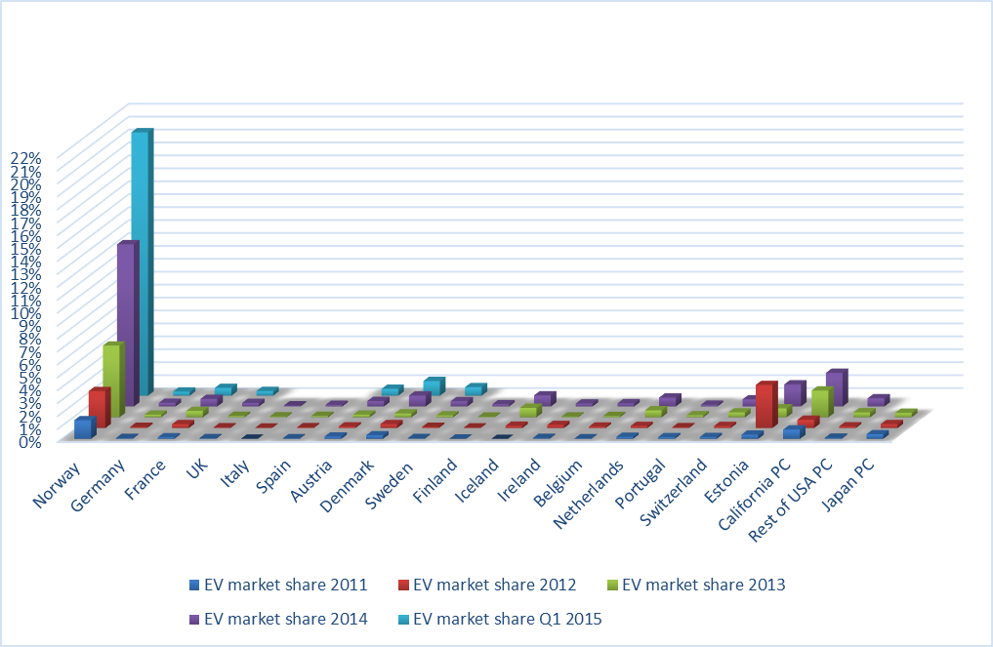
Figure 1 BEV market shares in Europe, USA and Japan 2011-2015. Percent. Sources: National statistics, webpages, historical sales material, for details see Figenbaum and Kolbenstvedt (2015).

The article uses Rogers’ (1962, 1995) theory of diffusion of innovations as a framework to understand the interplay between the society, the technology and the users from different perspectives and to identify efficient measures to support diffusion processes. The market expansion has been assisted by generous incentives towards BEV buyers, some of them available since the 1990s. The article focuses the effect and effectiveness of these incentives on the concrete diffusion locally, regionally and nationwide among different car user groups, and in the motor industry. A broader presentation of the political processes behind these incentives is found in Figenbaum (2016) and Figenbaum and Kolbenstvedt (2015a).

The following questions will be investigated in this paper:
- How did policy and incentives influence the relative advantage of BEVs?
- How has BEVs diffused regionally and among different users and markets?
- Which technical, societal, individual and communicative factors affected diffusion?

Norwegian context
The successful electric vehicle market in Norway is heavily incentivized as seen in table 1. The economic incentives, i.e. the exemptions from the vehicle registration taxes and the VAT, has made BEVs competitive against Internal Combustion Engine Vehicles (ICEVs). In the 1990s incentives were introduced to allow experimentation with electric vehicles. From around 2000 a growing BEV industry in Norway was nurtured. From 2010 the focus shifted towards supporting climate policy goals, as discussed in Figenbaum et al (2015). A target that the average new vehicle shall emit less than 85g/km in 2020 was introduced in 2012 (Norwegian Climate Policy 2012). In Norway road transport accounts for appr.19% of the GHG emissions (Norwegian Environment agency 2014) and must therefore contribute substantially towards national targets for reduction of greenhouse gas emissions (GHG). About 96% of Norway’s electricity is produced with renewable hydroelectric power (Figenbaum et al 2015). When replacing a combustion engine vehicle with a BEV, GHG emissions will independent of the national electricity mix, be reduced with 100% if the cap of emissions in the European Union Emission trading scheme for GHGs is effective (EU ETS 2015, Flere kilder?). Electrification of vehicles is thus an important climate policy measure and has been an integrated part of Norway’s climate policy since 2012 (Climate Policy Settlement 2012). The 2016 planning document for the National Transportation Plan suggests that only zero emission passenger vehicles, light duty vans and distribution trucks shall be sold from 2025, essentially phasing out fossil fuelled vehicles (NTP 2016). This target was in June 2016 included into the Parliaments agreement on the future energy policy (Stortinget 2016). The future taxation policy for the transportation sector, including the incentives for BEVs was settled in the parliament in May 2015 as seen in the last column of table 1.

Table 1 Electric vehicle incentives in Norway, adapted from Figenbaum and Kolbenstvedt 2015b.
Incentives | Introduced | Benefits for buyers of BEVs, influence on relative advantage | Future of the incentive as presented in the governments revised budget for 2015 (may 2015)
Fiscal incentives: Reduction of purchase price/yearly cost gives competitive prices
Exemption from registration tax | 1990/1996 | The tax is based on emission and weight and makes ICE vehicles more expensive. Example of ICEV taxes: VW Up 3000 €. VW Golf: 6000-9000 €, | Continued until 2020 and to be reviewed against the achievement of the Norwegian climate policy goals for 2020/2030. For ICEVs the registration tax will be tuned further to reduce emissions
VAT exemption | 2001 | Vehicles competing with BEVs are levied a VAT of 25% on sales price minus registration tax. | Unchanged through the end of 2017. Will consider replacing it with a subsidy scheme, initially at the level of the VAT exemption, then ramped down.
Reduced annual vehicle license fee | 1996/2004 | BEVs and hydrogen vehicles 52 € (2014-figures). Diesel rate: 360-420 € with/without particulate filter. | Half rate of ICE vehicles to be introduced 01.01.2018 and full rate from 2020, i.e. the incentive will be removed from that year.
Reduced company car tax | 2000 | The company-car tax is lower but BEVs are mostly not company cars. | This incentive may be removed from 2018
Direct subsidies to users: Reduction of variable costs and help solving range challenges
Free toll roads | 1997 | In the Oslo-area the saved costs are 600-1 000 € per year for commuters. Some places exceed 2 500 €/year | The government will appraise the environmental effects of introducing differentiated fees for toll roads and ferries based on the environmental characteristics of vehicles as well as a low rate for BEVs and ICEVs.
Reduced fares on ferries | 2009 | Similar to toll roads saving money for those using car ferries.
Financial support for normal charging | 2009 | Reduce the economic risk for investors in charging stations, reduce range anxiety and expand usage options.
Financial support for fast charging | 2011 | Fast charging stations increases BEV miles driven & market.
User privileges: Reduction of time costs and providing users with relative advantages
Access to bus lanes | 2003/2005 | BEV users save time driving to work in the bus lane during rush hours. High value in regions with large delays. | Local authorities may be given the possibility to introduce restrictions if zero emission vehicles hinder busses’ ability to navigate the bus lanes.
Free parking | 1999 | Users get a parking space where these are scarce or expensive and save time looking for a space. | Local authorities will be given the authority to decide whether this incentive is to continue in their jurisdictional district
Free charging |  | Not regulated in national laws, but is often bundled with free parking | Local authorities will be given the authority to decide whether this incentive is to continue

Theoretical framework
The consumer adoption of BEVs on the national scale in Norway will mainly focus on the period after 2010, when the users had options for real choices. Rogers’ theory of diffusion of innovations has been selected as the analytical framework as it is suitable for studying diffusion within markets and populations, assuming that policies and incentives are given exogenously. To study policy interventions, other theories such as Geels’ Multi-Level Perspective might be more suitable (Geels, 2012, Figenbaum & Kolbenstvedt 2015a).

The theory of diffusion of innovations
Rogers’ (1962, 1995) theory states that the rate of diffusion of innovations is influenced by:
- The innovation’s perceived attributes, being the most influential factor:
  - relative advantage versus the old technology
  - compatibility with user needs, values and norms
  - complexity, i.e. how easy it is to understand and put into use
  - trialability, i.e. the potential to test the technology out on a small scale
  - observability/visibility to new potential users.
- The type of innovation decision, for instance if the value to the user is depending on other users taking the innovation into use.
- Communication channels, i.e. how and by whom information is communicated.
- Nature of the Social System, e.g. norms, degree of interactions etc.
- Extent of Change Agent’s promotion efforts.

Incentives to speed up BEV adoption should address these factors, especially the innovations perceived attributes.

The communication processes underlying diffusion constitute a net between all the elements, and influenced by these, defines the role of the innovation in society. The processes of decision makers on several levels include five phases: Knowledge, persuasion, decision, implementation and confirmation or rejection (Rogers 1995). The knowledge of innovations diffuses through several media and social network communication channels, that may also be influenced by change agents aiming to speed up diffusion. Innovators take the innovation autonomously into use which also increase the visibility of the innovation to “opinion leaders”: These leaders speed up innovation through horizontal communication with their peers and to new layers of people in society through vertical communication. Later adopters rely on advice from these innovative and cosmopolite opinion leaders having a higher socioeconomic status.

Cities are in general more innovative, having universities and international contacts. More people are available making the number of innovators taking new technology into use higher, and the interpersonal communication networks larger (Pan et al 2012). Other aspects are, higher average incomes, increased visibility as more people see the innovation, and trialability since each BEV dealer may serve more people.

Most BEVs produced after 2010 have according to the users own estimate a typical on-road range in Norway of 80-130 km (Figenbaum et al 2014, Figenbaum & Kolbenstvedt 2016), depending on the season and topography. The exception being Tesla with range estimates of 300-400 km. A full recharge at home takes 7-10 hours. Users therefore need a dedicated parking spot with electricity for BEVs to be a convenient means of transportation. ICEVs are on the other hand possible to drive 600-800 km between fill-ups that take minutes at fuel stations. Incentives giving BEV owners other comparative assets, i.e. relative advantages, has therefore been essential in supporting diffusion by compensating for these inconveniences. Other factors of importance are improvements in safety, reliability and durability (Figenbaum et al 2014). Being a new technology, costs are high and availability of models limited. BEVs thus offer less extensive and less flexible mobility compared with a gasoline vehicle. Reduced local pollution, noise and home fill up of energy may on the other hand be perceived as advantages.

The social system consists of institutions with various interests, norms, habits, values and laws. Crucial societal framing factors for EVs are clear political goals supporting the use of the new technology, and the prevalence of a political and economic system supporting the goals with incentives. The latter is especially important for preventive environmental innovations based on societal needs, such as those aimed at GHG emission reduction, as these will have a slower rate of adoption (Rogers 1995). Recent studies of dissemination of preventive innovations (Jacobsen & Bergek 2011, van den Bergh et al 2011, Moch & Yang 2014) therefore stress the importance of societal support. Other framing conditions are geography, climate, travel habits and the electricity mix.

Diffusion pattern
Diffusion of successful innovations normally follows an s-shaped curve with five adopter groups successively adopting the innovation, and thus representing different steps in the process, c.f. table 2. After 10-20% adoption is reached, further adoption is self-sustaining, i.e. a critical mass is reached (Rogers 1995). Incentives and other framing conditions will cause some to adoption to an earlier point in time but could also result in setbacks, for instance if the experience with EVs is negative if range is too short for user needs or the vehicles are unreliable. Some early fleet users experienced such issues (Assum et al 2014).

The hypotheses are that diffusion of BEVs will be more successful when:
- Available models can meet user (consumer, society) needs and give relative advantages
- Society can speed up diffusion with incentives or giving compensatory assets
- Communication channels are in function, and supported by change agents.
Table 2 Overview of diffusion steps and the groups share of the market development. Groups adapted from Rogers (1995)
First step – Innovators  Initial 2% of market | The diffusion is slow at first. The first adopters are geographically dispersed cosmopolite innovators (2% of market) making a decision to adopt individually, with little influence from social networks. More adoption is expected in cities. They get their information from media, and international travels. They are rich enough that early adoption does not cause high risk. Few vehicle models, brands and segments are available and only locally.
Second step – Early adopters  Next 14% of market | Diffusion picks up when early well connected, richer than average adopters, intermediates between innovators and later adopters, starts buying. Opinion leaders in contact or proximity with innovators, typically living in cities or suburbs and having large social networks, speeds up adoption further. The number of models and brands increase and the technology will be available in more segments nationwide. Diffusion spread out radially from initial areas and to new areas via communication networks such as friends or social media.
Third step – Early majority  34% of market | The early majority starts adopting and diffusion goes main stream. Vehicles are available nationwide in the main volume segments from market leaders. Diffusion spread to all regions, and growth is large in all areas in larger overlapping circles.
The fourth step – Late majority  34% of market | The late majority starts adopting. BEVs are now seen as a regular option alongside gasoline and diesel vehicles. All brands sell BEVs in different segments catering for brand and segment preferences. The diffusion circles around cities have become so large that overlaps create adoption regions. Diffusion is high in all parts of a country.
The final step – Laggards  16% of market | In addition, laggards adopt, and more remote regions starts adopting. The diffusion growth rate slows down, and diffusion eventually reaches its maximum potential as all potential adopters have adopted.

The authors assessment of the expected diffusion pattern on a national scale is shown in figure 2. In principle, three processes occur at the same time, adoption within a region, expansion of adoption to new regions and an expansion in the supply of models in more segments. Eventually the market will cover the entire nation and automotive sector.

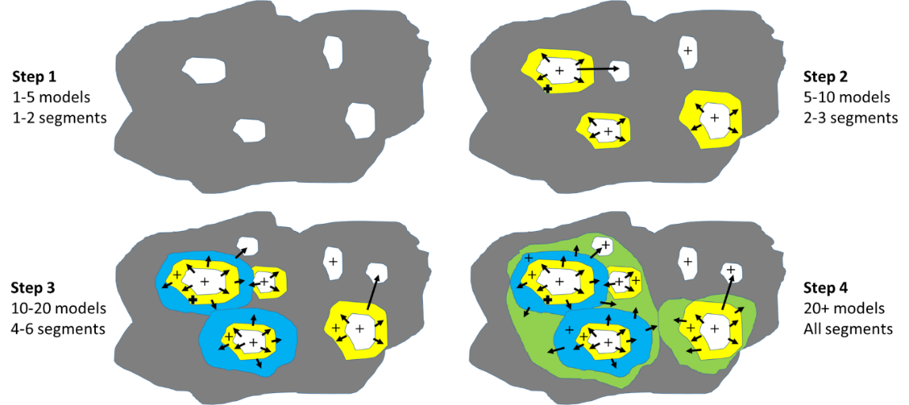
Figure 2 Authors assessment of the expected pattern of market diffusion, the first four steps, c.f. table 2, taken into account. White are initial areas; + signs illustrates a deeper diffusion within areas where EVs have been taken into use. Arrows mark diffusion to new areas with increasing distance to the original areas with yellow, blue and green colour.

Material and method
Consumer attitude to, and behaviour and experience with, battery electric vehicles was surveyed by the COMPETT Electromobility+ project. 1721 nationwide BEV owners belonging to the Norwegian EV association and 2241 random ICEV owning people from members of the Norwegian Automobile Federation (NAF) in the Oslo region, responded to a survey in January and February 2014 (Figenbaum et al 2014). ICEV owners were divided into those expressing an interest respectively no interest in buying a BEV. Survey links was sent out in a newsletter from the EV association and in an e-mail to NAF members. The response rates were 22-40% depending on assumptions made on how many saw the newsletter link (Ibid).

At that time little knowledge existed on the usage of the latest generation BEVs. Reviews of international BEV related surveys (Hjorthol 2013) and of 20 earlier Norwegian surveys (Figenbaum & Kolbenstvedt 2013) were used to identify factors of relevance to BEV adoption and as inputs to the survey formulation. The questionnaire should cover as many as possible of the relevant topics and make it possible to identify characteristics of BEV owners and their motivations. Some question should be compatible with earlier surveys to follow changing attitudes to BEVs. It should also be possible to compare with data from the Norwegian national travel survey. The rapid development of BEVs makes comparisons with earlier surveys complicated. The vehicles available in 2014 and 2016 were not comparable to the ones commonly in use in 2010 and earlier. The survey of ICEV owners contained a subset of the BEV owner questions, with the addition of questions related to their knowledge of and attitudes to BEV.

A new user survey, with many of the same questions was repeated in March 2016, this time with 3111 BEV respondents and 2080 ICEV respondents as well as Plug in Hybrid (PHEV) owners (Figenbaum & Kolbenstvedt 2016).

In addition, interviews were conducted with stakeholders from government, local authorities, NGOs, consumer organizations, car importers and car dealers April to September 2014 (Assum et al 2014). Facts on incentives, the timeline of BEV introduction, the Norwegian BEV history (Figenbaum & Kolbenstvedt 2013) and geographical BEV registration statistics from the national vehicle register (NPRA and the EV Association 2008-2014)), Statistics Norway (2013, 2014) and other sources, are also used to explain the diffusion process.

Observed diffusion
When looking at the diffusion into the fleet and in new vehicle sales and market shares, one must take into account the number of models available in each segment, and the supply of BEVs being limited or not. The first model in unlimited supply, the Mitsubishi I-Miev (Mitsubishi 2010), became available in Norway in 2011. That year will thus be selected as the starting year of the regular BEV diffusion. BEVs available prior to 2011 where constrained to small volumes and limited dealer coverage (Figenbaum and Kolbenstvedt 2013).

National BEV fleet
Prior to 1998, only some niche experiments were carried out and the number of BEVs in the fleet reached 146 in 1998 (Asphjell et al 2013). The fleet increased slowly through the 2000s, as consumers became the main buyers. In the beginning of 2010, the number of BEVs in Norway reached 3000 (Figenbaum & Kolbenstvedt 2013) and increased rapidly from 2011 as the traditional vehicle manufacturers launched their models one by one, reaching 70 000 BEVs, or 2.8% of the total Norwegian passenger car fleet in 2015.

Market development from 2011
The market share of BEVs of total new passenger vehicles sales for Norway reached 1.4% in 2011, 2.9% in 2012, 5.5% in 2013 and 12.6% in 2014 with some 16500 new vehicles sold and 2800 second-hand BEVs imported. In 2015 the market share reached 18%. Some provinces had market shares above 20% (OFVAS 2016). The number of available models and segments with BEVs available has increased over the years. In 2010-2012 the diffusion of vehicles and segments was in step 1 according to figure 2, step 2 was reached in 2013, and step 3 from 2014, supporting diffusion into the early majority consumer group.

Figure 3 shows that the general tendency is that, contrary to intuition, the BEV models already on the market keep most of the sales volume when new models enter the market. This situation has contributed significantly to the rapid diffusion of BEVs. After 2014 the BEV market has been dominated by Volkswagen and the compact vehicle segment. Sales have been somewhat reduced in the first half of 2016. Buyers are potentially waiting for new models with longer range to arrive such as the BMW i3 with over 300 km range.

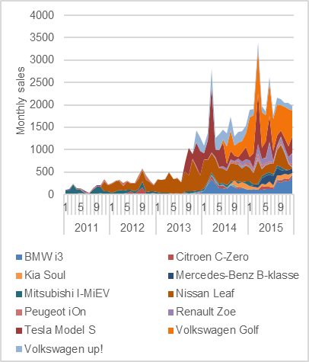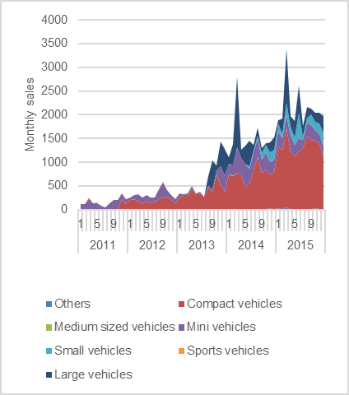
Figure 3 BEV sales per month by model and brand (left) and segment (right). Source: OFVAS (2016).

Several brands have high share of BEVs of total sales as seen in figure 4. VW E-Golf would for instance have been the bestselling model in 2015 in Norway if counted separately.

Figure 4 Share of BEV, PHEV and ICEV sales in 2015 by brand that sells BEVs in Norway. Source: OFVAS 2016.

Regional and local diffusion
The number of municipalities without BEVs has gone down rapidly, see figure 5. Only 5% of the municipalities had no BEVs registered in December 2015. In 2008, none had more than 2% BEVs in the fleet. In December 2015, the share was 24%.

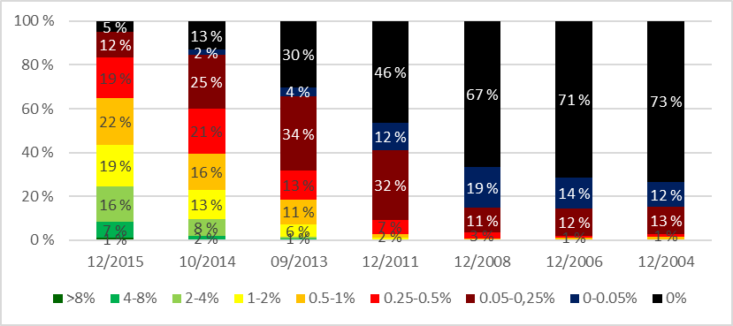
Figure 5 The expansion of BEVs within 428 municipalities in Norway 2004-2015. Share of BEVs of total fleet 1st of January each year in intervals. Data from the NPRA and the EV association (2008 – 2014), OFVAS (2012, 2014), Statistics Norway (2004, 2006).
The diffusion started in cities and their neighbouring municipalities and then spread radially further out. The diffusion pattern of BEVS is clearly visible with increasingly larger circles of high BEV density of municipalities around Oslo. This pattern is also discernible around the other Norwegian cities. The six largest cities in Norway had a BEV fleet share from 4 – 6% in 2015. An increase in the adoption rate also occurred within each municipality, as seen in figure 6.
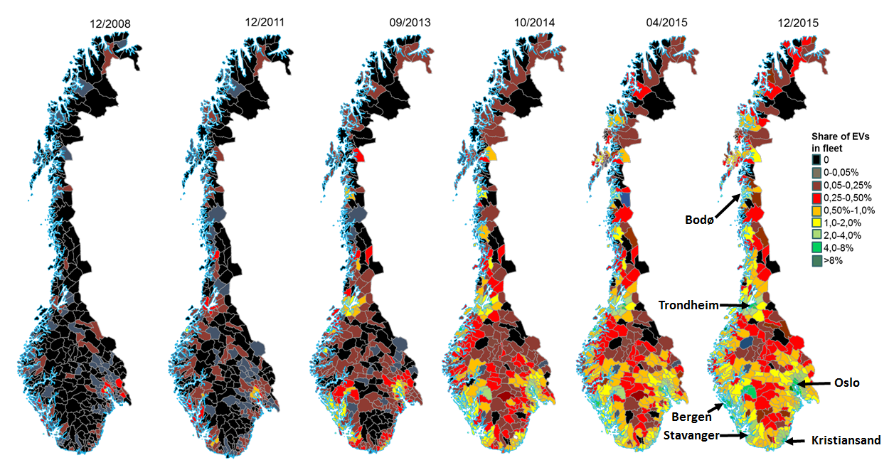
Figure 6 Geographical diffusion of BEVs in Norway’s 428 municipalities 2008-2015,). Share of BEV in total fleet. Made by authors with data from the Norwegian Public Roads Administration and the EV association, OFVAS (2016), Statistics Norway (2016).

The top three adopting municipalities are areas with expensive toll roads related to underwater tunnels and thus substantial savings for BEV owners. Their fleet rates vary from 10 – 17%. An example is Finnøy, the first municipality to reach 10% adoption and a 2015 fleet rate of 17%. BEV owners there can save up to 30 000 NOK per year in reduced toll road costs. The next six municipalities on the top 10 list consists of typical suburbs around cities where people commute through toll rings and can use bus lanes. The only city on the top ten list, Bergen, the second largest city in Norway, is on 10th place.

The regional diffusion seems to have been at step 1 up to 2010 and step 2 from 2011-2014, potentially reaching into step 3 from 2015-2016.

BEV density by postal code zone is shown for Oslo, Bærum and Asker in figure 7. The density is highest, up to 45%, in postal zones with BEV dealers and few inhabitants. BEV densities are otherwise higher in areas with high income, long distances to Oslo, and where driving in the bus lane is an advantage, and in zones outside the toll-road ring around Oslo or far away from metro and train lines. Low BEV densities are seen where households have metro or train lines closely available, no bus lanes, and those located inside the toll-road ring where private parking facilities, may be a limiting factor, (Figenbaum and Kolbenstvedt (2015a).

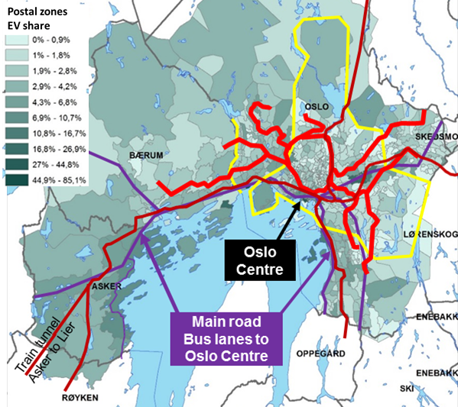
Figure 7 BEV density (BEVs per 1000 vehicles) by postal code zones in Oslo, Asker and Bærum. Yellow lines mark the toll ring around Oslo and the toll gates between Oslo and Bærum. Red lines are the metro network, dark red the main train lines, purple is main roads. Figure from Figenbaum and Kolbenstvedt 2015a, Data from the NPRA and the EV association (2008-2014).

BEV owners, coming buyers and non-buyers
Studies of early adopters of BEVs indicate common socio-demographic characteristics across countries (Hjorthol 2013, Hjorthol et al 2014, Figenbaum & Kolbenstvedt, 2013, Figenbaum et al 2014, Figenbaum & Kolbenstvedt 2016). The early adopters are relatively young, a majority are men, having high education and income, belonging to households with more than one car in or in vicinity of larger cities). They have large transportation needs, with children under age 18 living in the household, and longer than average distances to work (Ibid). Working, highly educated, and well off, they have a positive perception of BEV technology playing down the disadvantages and seeing the advantages of BEVs. In total, they do not differ much from other multi-vehicle households in socio-demographics (Ibid).

ICEV owners stating that they will not buy an BEV, are older, have lower education, fewer children, lower income, and a lower employment rate (Figenbaum et al Elvebakk 2014, Figenbaum & Kolbenstvedt 2016). Fewer are multi-vehicle owners, and they have a more negative opinion about BEVs compared to car owners at large. Those stating that they will consider buying a BEV, are found somewhere between the BEV owners and those who will not consider BEVs in socio-economic background (Ibid). The largest potential for further diffusion lies in the early majority, i.e. persons who consider buying an BEV or have not made up their minds. Those, who will not consider BEVs, constitute the late majority and laggards.

Factors affecting diffusion

National characteristics
In Norway, electricity is produced almost exclusively (96%) by hydroelectric power plants (Figenbaum et al 2015). Norwegians consider electricity as emission free and it is easily available at moderate prices (Ibid). 89% of households have a parking space available at their house, 84% of these have it on own land (Hjorthol et al 2014) making it feasible to recharge a BEV at home. Four of ten ICEVs are equipped with electric engine block heaters (Bilnorge 2010) to facilitate cold starts. Norwegians are thus used to plugging vehicles into the grid, making BEVs less complex to take into use.

The cold winter causes range to be reduced by 30% (Figenbaum et al 2014), even up to 50% in severe cases (Haakana et al 2013). Diffusion has thus as expected proven to be slow in the coldest and less densely populated areas, as seen in figure 8.

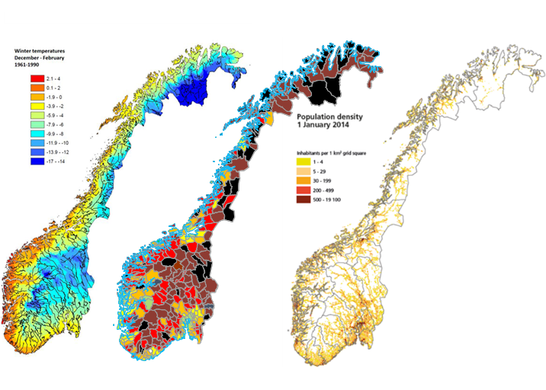
Figure 8 Winter temperature (to the left), BEV density 2014 (in the middle) and population density (to the right) in Norway. Source: Left map: Haakana et al (2013), Middle map: 2014 BEV status, see figure ….. Right map: Statistics Norway (2014).

Norwegian BEV incentives
The comprehensive package of BEV incentives has led to more and other adopters than the theory of diffusion of innovation predicts by moving consumer adoption to an earlier point in time. Adoption have become feasible for less affluent consumers by levelling out the price difference between BEVs and ICEVs through the tax policy, further aided by technology cost reductions, as seen in figure 9.

The rate of diffusion in Norway indicates that the incentives and policies presented in table 1, have addressed many of the barriers to BEV adoption. Niche markets have been created and have formed a base to grow from, such as bus lane users, users in areas with toll roads, users looking for parking spaces in crowded city centres etc. It is not likely that many people would have bought the first expensive and rather primitive vehicles of the early 2000s without substantial incentives, as seen by the high price differential between the price of the cheapest BEVs and ICEVs in figure 9, and the slow adoption of BEVs in the beginning.

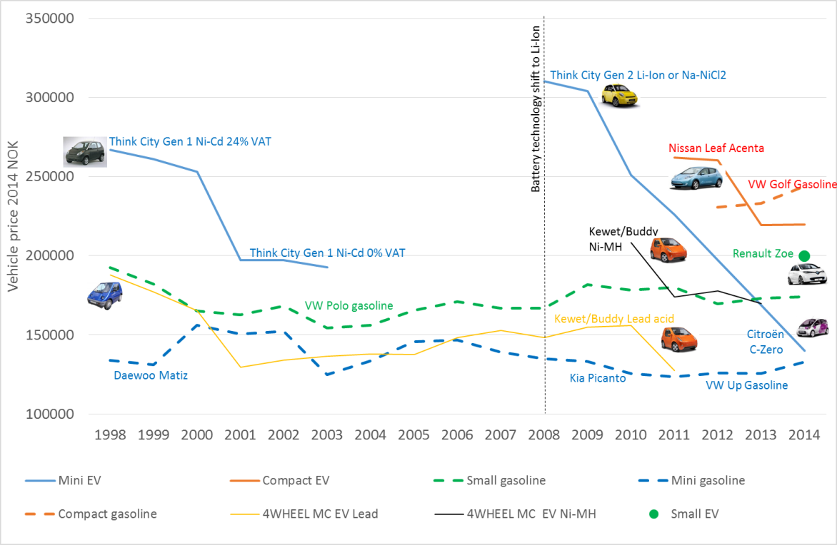
Figure 9 Sales prices of some BEVs in Norway compared with gasoline vehicles. BEV prices are without all taxes according to the incentives. ICE vehicle prices include all registration taxes and VAT. Sources: Taxnorway 2015, Bilpriser (1998-2014), webpages, news articles, historical sales material.

The technologies attributes have evolved over time
The BEV technology has improved substantially over time. In the early 2000s, the real world range (what users experience over the seasons) was typically 40-80 km. No fast chargers where available. From 2011 vehicles with ranges of 100-150 km appeared, which had a fast charge capability. Tesla launched the Model S with an on-road range of 300-450 km (author’s estimates) in 2013. These improvements are mainly due to maintenance free Li-Ion batteries with high energy density coming on the market and improved climate controls using heat pumps.

Battery warranty has gone up from 2 years for Ni-Cd batteries used around 2000, to up to eight years 200 000 km warranties for 2016 models. The life of batteries has proven better than initially expected, and worries over battery replacement cost has been reduced among consumers between 2014 and 2016 (Figenbaum & Kolbenstvedt 2016), as illustrated by a big reduction in consumers concern over the second hand value of BEVs.

A network of about 300 (Elbil 2016) fast chargers are now located along main roads and in cities, facilitating longer distance driving.

The safety of BEVs has improved dramatically from the (Høye & Figenbaum 2015) early 2000s small rather basic BEVs. BEVs now achieve 4-5 stars in EuroNcap crashtest, as ICEVs do (EuroNcap 2014).

Communication channels
Social networks play a large role in the pace of diffusion of new technologies according to Rogers (1995). In the beginning, prospective buyers typically get the information inspiring a purchase from media. Figure 10 present the yearly press coverage of BEVs, measured as the number of articles published, together with the growth in the BEV fleet.

Figure 10 Press coverage of BEVs (red line) and annual growth of number of BEVs (blue line) in Norway between 1997 and 2015. Sources: Figenbaum and Kolbenstvedt (2015a) and Retriever (2016).

The press coverage was low until 2007, when a rapid increase led up to a higher level from 2009 to 2012, coinciding with announcements of new BEVs from vehicle manufacturers. 2013 and 2014 have seen another large increase in press coverage. The three-year gap between increase in press articles and the increase in the fleet between 2007 and 2010, is potentially linked to BEVs being high on the agenda while few vehicles were available at dealers.

According to the theory, diffusion will at a later stage speed up when more insecure and cautious prospective buyers get reliable information from their peers. In the 2016 survey, BEV respondents on average said they had inspired 1.2 of their peers to buy and 1.2. to consider buying BEVs, after having told them about their BEV experience, c.f. figure 11.

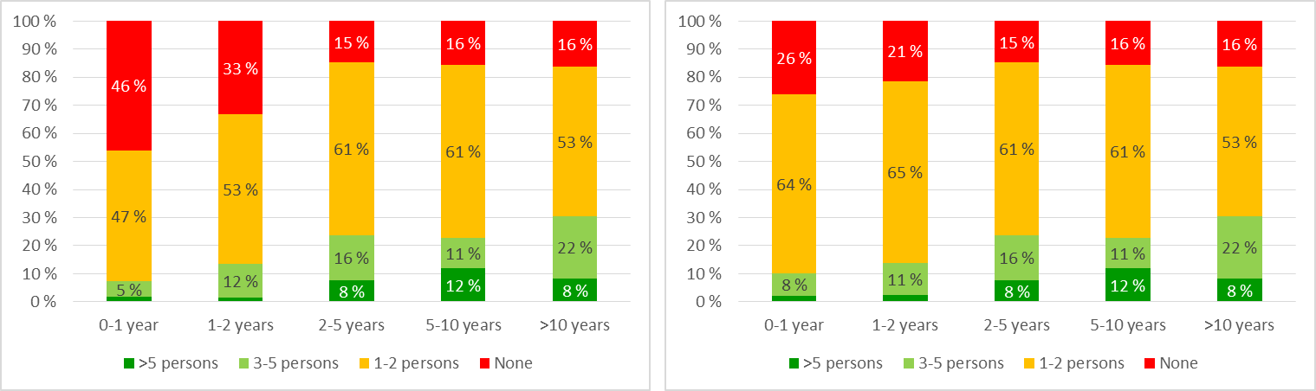Figure 11 Number of friends/family t BEV owners say they have inspired to buy BEVs (left) or consider buying (right), by years as BEV driver, “don’t know” answers not shown. n_{0-1year}=1397, n_{1-2year}=807, n_{2-5year}=736, n_{5-10year}=111, n_{>10year}=61. Source: Figenbaum & Kolbenstvedt 2016.

Change agents may influence the rate of adoption of innovations according to Rogers (1995). In Norway, several types of change agents active in targeting increased BEV adoption, have been operational. Transnova, (a government agency operation from 2009 to 2014, now transferred to Enova), promoted cleaner energy and charging infrastructure deployment and demonstrations. Grønn bil was an organization funded by Transnova that nudged fleets to adopt BEVs (Assum et al 2014). The EV association is a change agent promoting BEVs and keeping guard over the political framework for BEVs (Ibid). It is also a change aide supporting members for instance with a charging infrastructure database and a guide for buying BEVs (Ibid 2014). Both environmental and car owner NGOs have acted as change agents by successfully lobbying to get the registration tax exemption for the first BEV imported to Norway in 1990, and toll road exemption in Oslo in 1997 (Figenbaum & Kolbenstvedt 2013) Together with municipalities such as Oslo and Stavanger they lobbied the government to allow free parking for BEVs from 1999 (Asphjell et al 2013). Some vehicle importers cooperate actively with these organizations (Assum et al 2014), and BEV dealers give buyers free membership in the EV association.

A network of business and change agents pulling in the same direction has thus been established substantially aiding and smoothening the diffusion process.

User perception
Relative advantage
The users relative advantage of taking a technology into use is the most important factor in a diffusion process. Table 3 illustrates how the Norwegian incentives aid in turning BEV ownership into an advantage already for the first vehicle owner, thus being key to the Norwegian BEV success.

Table 3 Elements of Relative advantage. Authors overall assessment of first owners’ evaluation of the potential of each element without and with the Norwegian BEV incentives. Adapted from Figenbaum and Kolbenstvedt 2015a.
Elements of relative advantage | Without incentives | With Norwegian incentives
Economic profitability | Vehicles are too expensive and expected second hand value after 3-5 years is low. | Profitable for first owner, but the risk of second-hand value still relevant. Vehicles bought 2010-11 have potentially been unprofitable even in Norway due to the falling new-vehicle prices.
Low initial cost | BEVs are more expensive than ICEVs. Value added tax expands the cost gap. | Equalizes the price in smaller vehicle segments and make BEVs cheaper than ICEVs for larger vehicles
Decrease in discomfort | Discomfort due to range limitations although many uses are compatible with range limits. | User advantages ncreased comfort and assure that BEVs are in accordance with societal goals. People can afford buying. Concerns of second-hand value are reduced as owner save on operative costs and incentives.
Saving of time and effort | More effort needed, i.e. planning the transport, range challenges, time to plug in the vehicle, borrowing vehicles when needed. | The effort of planning is reduced by time saving using bus lanes. Vehicles are cheap enough to be taken into use by multi vehicle households capable of handling range challenges.
Immediacy of reward. | The vehicle is too expensive and the savings per year on fuel too low, and the second hand value is uncertain. | Time and cost savings are immediately achieved with low energy costs, low annual tax, free toll roads, reduced ferry rates and bus lane access.
Social Prestige | Teslas and BWM i3s give prestige, but basic BEVs could be negative due to poor value proposition? | Everyone can buy a BEV, thus democratizing BEV diffusion, but also reducing social prestige.
Environmental prestige | Not a dominating motive initially | Increase as a motive after buying a BEV. A possible negative factor is that it becomes easier (morally) to justify buying a second car.

Compatibility and complexity
A BEV is driven and controlled as an ICEV with automatic gear, and is sold and serviced through regular OEM dealers. Short range and long charging times lead to a need to recharge the vehicle at home. These main incompatibilities of BEVs compared to ICEVs have proven to be tolerable in households having access to more than one vehicle. About half the vehicle owning households in Norway (Hjorthol et al 2014) own more than one vehicle. 21-25% of BEV owners only have the BEV in the household (Figenbaum et al 2014). In households with one vehicle, range will be incompatible for some of the driving but will be manageable for most daily travel (ibid). The user surveys in 2014 and 2016 found that BEV owners have annual driving distances on par with ICEVs (Figenbaum et al 2014, Figenbaum and Kolbenstvedt 2016), which seems to be confirmed by Nissan (2014) vehicle usage statistics for Norway. Cities such as Oslo have put up charging stations in city centres. A national network of fast chargers has been deployed with support from government organisations such as Transnova and Enova, thus improving BEVs compatibility with user needs. The bus lane access from 2003 allowed more early adopters to use BEVs to drive to work, saving time as compensation for the short range, limited comfort and reduced reliability of early BEVs.

27 % of users have experienced to forego trips and 6% have aborted trips (Figenbaum and Kolbenstvedt 2016). The rest have few problems covering their travel needs, indicating that BEVs are compatible with most driving needs of the current owners. The average driving pattern from the national travel surveys indicate that the driving needs of households should have led to more issues given the number of days an average person should experience range challenges presented in figure12. That data does however not take into account that long distance driving in multivehicle households can be covered by the other vehicle, which in most cases is an ICEV (Figenbaum & Kolbenstvedt 2016). There is likely also a self-selection mechanism involved, where the first buyers have driving patterns better matching BEV characteristics than average vehicle owners have.

Studying the total distance as a car driver on an average day, Hjorthol et al (2014) found that as many as 88% of all drivers will have no need for recharging a BEV during an average day when assuming summer/winter ranges of 120/80 km. 4% of the trips, 6% of the trip chains (sum of trips starting and ending at home) and 12% of the days during a year exceed the range limit. In a year, the BEV range (without recharging during a days driving) is thus exceeded 43 days for average vehicle owners, see figure 12. On such days, recharge during the day will be required and can be done when stops are long enough, and conditions suitable (typically home or work).
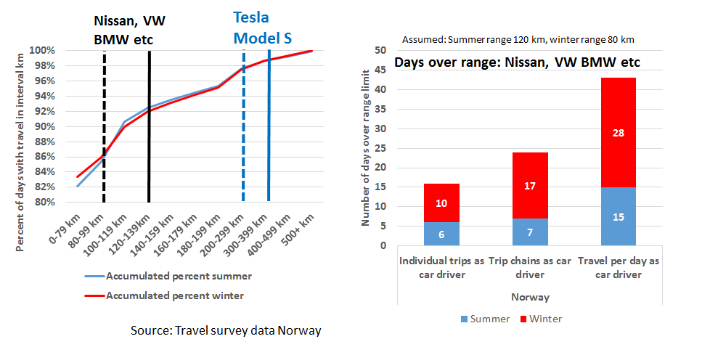
Figure 12 Average driving length in km per day in the national travel survey 2009 (?) by distance interval (left), and the number of days over range for trips, for trip chains and for total daily driving length (right). Source: Figenbaum et al 2014.

Range anxiety (the fear of being stranded due to a depleted battery) is ubiquitous, but the range of new BEVs keeps increasing. However, some trips or trip chains cannot be made, and the BEV owners must take other measures i.e. saving energy while driving, borrowing or renting vehicles or swapping cars within the household, as seen in figure 13. Comparing these results with 2016 results (Figenbaum & Kolbenstvedt 2016), indicate that owners have become less inclined to loan or rent vehicles and more inclined to use fast chargers and drive more efficiently.

Figure 13 Different adaption strategies to avoid range challenges in multicar BEV/ICE and BEV-only households. Source: Figenbaum et al (2014).

The availability of fast chargers is one of the factors influencing BEV adoption, allowing charging on the go and in emergencies. The average BEV owner used fast chargers about 14 times per year in 2014, increasing to 16 times in 2016 (Figenbaum et al 2014, Figenbaum & Kolbenstvedt 2016). A chaos of different payment systems for fast charging however makes usage more complex than it need to be and there has been issues with the technical stability of fast chargers. BEV sales have also outpaced the expansion of charge stations, so that available charge stations per BEV are reduced, c.f. figure 14.

Figure 14 Development of charging structure. BEVs per public chargers, normal and fast chargers 2010 – 2014 in Norway. Data sources: Gronnbil (2015), OFVAS (2014).

A strong indication of BEVs compatibility with user needs is that a large majority, 87% of the current BEV owners, say they will buy an BEV next time they buy a car (Figenbaum et al 2014, Figenbaum & Kolbenstvedt 2016). The corresponding figure for the average ICEV owner is that 30% will consider buying one.

Trialability and observability
Trialability is important (Rogers 1995) in the early phases of diffusion of innovations. The first adopters have no peers who have adopted already, and thus less information available. Therefore, they need to try a BEV to see if it works for them. The import of second-hand vehicles from 2003 up to 2009 kept the BEV market alive, by allowing BEVs to be tried out in some of the cities in Norway in a period when most countries and vehicle manufacturers had abandoned BEVs. As diffusion catches on, more potential adopters will have BEV owning peers providing reliable information on BEVs. Test drives will then be easily accessible and more dealers will sell BEVs, thus eliminating the trialability issue.

The EV association and the Norwegian Automobile Federation (NAF) arranged events increasing BEV visibility such as BEV parades and races, international conferences, as well as ride and drive events, in the earlier years of BEV diffusion. The visibility and trialability of BEVs is larger in Norway than other countries. BEVs have been equipped with EL number plates since 1999, and BEVs in the bus lane pass a large number of vehicles during the rush hour. Norwegians living in cities now see BEVs in real traffic situations every day. They constituted over 5% of the vehicles driving through the toll gates into Oslo in 2015 (Fjellinjen 2016). The large increase in BEV-dealers between 2010 and 2014, as seen in figure 15, increased visibility and exposure where people look for vehicles to buy.

Figure 15 The number of dealers and models available in Norway 2011-2014. Sources: Compiled from the importer websites. OEM=Original equipment manufacturers.

Discussion
In the introduction, three questions about the BEV diffusion process in Norway was raised:
- How did policy and incentives influence the relative advantage of BEVs?
- How has BEVs diffused regionally and among different users and markets?
- Which technical, societal, individual and communicative factors affected diffusion?
Results relevant to these questions have been presented and the results are discussed in the following sub sections.

Policy and incentives influence on the relative advantage of BEVs
The Norwegian government have over two and a half decades introduced one BEV incentive after the other, summing up to a forceful package providing BEV buyers with unique advantages such as, access to bus lanes, free parking and free passing through toll road gates. BEVs are now as cheap as ICEVs in smaller vehicle classes and cheaper than ICEVs in larger vehicle classes. In principle, everyone buying a new vehicle can afford BEVs in Norway thanks to the substantial purchase incentives. BEV owners have thus experienced that BEVs have relative advantages over ICEVs. The continuation of the diffusion process will rely on incentives being available for some time into the future.

Diffusion of BEVs among different users and markets and geographically
The characteristics of early BEV owners match many of the characteristics of early user groups in Rogers’ theory of diffusion, being younger university educated full time working men living in households with children, in the outskirts of cities.

From the data on regional diffusion, it is evident that BEVs were first taken into use by self-contained innovators living in cities and in some municipalities with particularly large local incentives. They typically got information about the technology from media. BEVs spread out radially from these initial municipalities to neighbouring municipalities, and within each municipality, supported by the information exchange in interpersonal networks after early adopters started adopting. The visibility and trialability increased rapidly through this initial diffusion leading to even more rapid adoption. BEVs where in 2015, five years into the main diffusion process, present all over the country. Municipalities that had no adopters by the end of 2015, are the least likely to adopt, having cold climates and long travel distances.

The automotive BEV market diffusion however, in some aspects complies with, and in other aspects differs from the theory. Contrary to the general picture of diffusion of vehicle innovations from luxury to smaller vehicles, the BEV fleet in Norway evolved from small domestically produced BEVs. Later it became dominated by small, compact vehicles from traditional automakers. Some Norwegian provinces have even reached BEV market shares above 20%, theoretically beyond critical mass indicating a self-sustaining further diffusion. These regions are however too small to drive a diffusion process by themselves. BEVs make up a substantial part of total vehicle sales for manufactures with BEVs available, and models with BEV and ICE versions have high BEV shares. When new BEVs are launched, new BEV customers are recruited. Sales however depend strongly on the popularity of a few models, making the diffusion process vulnerable to changing preferences.

Technical, societal, individual and communicative diffusion factors
The compatibility with user needs have been achieved in multivehicle households: They have had few challenges putting BEVs to use in daily transportation activities. They have the option to swap vehicles in the household, and range is thus no barrier to adoption. Some households that have only BEVs have also found ways to cope with range limitations. Incentives for charging infrastructure have been important to reduce range anxiety in this group.
Early adopters can be located anywhere in the country as incentives are unlimited and available nationwide. Some of the incentives have provided a geographical means to spread BEV technology for instance when new toll roads have been established.

Trialability has been possible in niche markets. With the BEV share of the fleet passing 2.8% in 2015, most Norwegians now know someone that owns and operate BEVs, that can provide reliable information and it makes it easy to test them. Observability and visibility have been achieved by adopting specific number plates for BEVs and drivers have seen BEVs pass by in the bus lanes during rush hours. These long term policies allowed consumers to gradually become accustomed to BEVs. The market has moved beyond early users into the early majority group, a vital step in diffusion of innovations.

The communication process has supported BEV diffusion through the development of new types of organisations helping users and the car industry. New channels for cooperation between organisations, public authorities and the car industry have been introduced and the communication has mostly been positive. The rapid development in the market and the technology have been leading to a large media exposure that helped the initial market to grow. A large share of BEV owners now reports that they got information from friends or family, which has higher “quality” in the diffusion process than information from the press. Diffusion agents have been successful in getting incentives established and keeping guard over their continuation.

Overall assessment
During the diffusion period, important changes in crucial decisive factors have occurred. These changes make the basis of our understanding of the Norwegian success. The BEV technology changed and a BEV sold in 2015 is not the same as those sold earlier. Batteries last longer, range is increased, and BEVs now cover most daily trips. The BEV characteristics now resemble ICEVs in comfort, purchase price, quality, durability, safety and reliability, though deviating when it comes to range and recharge. The users’ needs have not changed, but their attitudes have become more positive over time, helped by interpersonal communication with peers, their own experiences and improved technology. They have also got a more positive attitude to the environmental aspects of electric vehicles.

The diffusion seems to have gone at maximum speed over the past. The users’ needs have been met. Prices are competitive, and local user incentives give BEV owners relative advantages over other vehicle owners. The majority of users find that an BEV is the best car for their need, meeting daily travel needs. BEVs are now driven as much as other vehicles per year, a further indication of their utility for users. People learn to cope with range limitations. Multi-vehicle households have minor problems adapting, whereas single vehicle households may drop a journey or borrow an ICEV. Both groups say they will continue to buy BEVs.

The support given by political goals and incentives has increased immensely during the last twenty years. Incentives were necessary to bridge the cost gap between BEVs and ICEs. Incentives have given BEVs the necessary relative advantages motivating a purchase. BEVs have become competitive through cost reductions. Incentives nudge consumers into buying BEVs rather than ICEVs.

Conclusion
Norway has developed and introduced a broad spectre of incentives, resulting in the largest BEV diffusion in the world. Norway has become Norway has become an arena for testing the effectiveness of electromobility incentives. Improved technology and reduced costs combined with these incentives have resulted in Norwegian BEV buyers experiencing that BEVs have many relative advantages over ICEVs. The limited range is not a hindrance to adoption in user groups such as multi vehicle households. Since the prices of BEVs have been reduced, the batteries improved and more brands are selling BEVs, less incentives will be needed to promote BEVs in the future. Heavy incentives are efficient in making the diffusion speed up, but with the risk that the market will not be sustainable when they are removed or downsized as the motivation to continue adoption may be reduced. Incentives may, however, make people buy vehicles that they discover are useful for more of their transport needs than initially thought, especially so since they offer a possibility of environmental friendly driving.

An achievement of the BEV policy is that national, regional and local governments, businesses and NGOs have been motivated to move in the same direction and this could serve as a guiding line for developing other nations BEV markets.

There is potential for future growth supported by communication in interpersonal networks and the availability of new longer-range models attracting new customer groups.

The diffusion of BEVs in Norway closely resembles what is expected from diffusion theory, proving the usefulness of the theory in analysing diffusion of innovations in markets where policies are stable. The future rate of diffusion will be heavily influenced by possible modifications to the societal and economic framework and cooperation. The Norwegian BEV market is, however, also depending on other markets. If diffusion does not catch on in Europe, the diffusion may slow down. Also the influx of PHEVs into the market from 2016 could affect BEV diffusion.

Acknowledgement
This paper is a result of the project Compett (Competitive Electric Town Transport), financed jointly by Electromobility+, Transnova and The Research Council of Norway, FFG of Austria and The Ministry of Science, Innovation and Higher Education (Higher Education Ministry) in Denmark. The Compett project was a co-operation between The Institute of Transport Economics in Norway, The Austrian Energy Agency, The University College Buskerud in Norway, Kongsberg Innovation in Norway and the Danish Road Directorate.

Bibliography
Asphjell, A., Asphjell, Ø. and Kvisle H. H. (2013). Elbil på norsk 2013. ISBN 978-82-7704-142-1. Trondheim, Transnova. (Norwegian language).
Assum, T., Kolbenstvedt, M. and Figenbaum, E. (2015). Potentials, barrieres and the future of elctromobility in Norway. Stakeholders perspectives. TØI report 1385/2014. Institute of Transport Economics 2014.
Bilnorge (2010). Better climate with engine block heater (in Norwegian). News article 07.12.2010. Bilnorge.no
Bilpriser/Car prices (1998-2014). Partly from “Bilpriser” a yearly list of vehicle prices published by OFVAS and made available by the tax collectors office. Authors collection of BEV market prices partly from old media articles, partly from importers price lists. Consumer price indexed to 2013 prices.
Climate Policy Settlement (2012). Innst. 390 S (2011-2012) To the Norwegian parliament from the Energy- and environment committee.
Elbil 2016. Dette koster hurtiglading (in Norwegian). http://elbil.no/dette-koster-hurtiglading/. Newsarticle on the website of the Norwegian EV Association.
EU ETS (2015). The EU Emissions Trading System (EU ETS). http://ec.europa.eu/clima/publications/docs/factsheet_ets_en.pdf
EuroNcap (2014). Crash test data for EVs and ICE vehicles retrieved from www.euroncap.com.
Figenbaum, E., Kolbenstvedt, M. (2013). Electromobility in Norway - experiences and opportunities with electric vehicles. TØI report 1281/2013, Oslo, Transportøkonomisk institutt.
Figenbaum, E. (2016). Perspectives on Norway’s supercharged electric vehicle policy. Article under review, submitted to Environmental Innovation and Societal Transitions.
Figenbaum, E., Kolbenstvedt, M. (2016). Learning from Norwegian Battery Electric and Plug-in Hybrid Vehicle users. Results from a survey of vehicle owners. TØI report 1492/2016. Institute of Transport Economics.
Figenbaum, E. Kolbenstvedt, M., Elvebakk, B. (2014). Electric vehicles – environmental, economic and practical aspects. As seen by current and potential users. Compett and TØI report 1329/2014. Institute of Transport Economics.
Figenbaum, E., Kolbenstvedt, M. (2015a). Pathways to electromobility - perspectives based on Norwegian experiences. TØI, Report 1420/2015. Institute of Transport Economics.
Figenbaum, E., Kolbenstvedt, M. (2015b). Competitive Electric Town Transport. Main results from COMPETT – an Electromobility+ project. TØI report 1422/2015. Institute of Transport Economics
Figenbaum, E., Assum, T., Kolbenstvedt, M. (2015). Electromobility in Norway – experiences and opportunities. Research in Transportation Economics in 2015. Volume 50, August 2015, Pages 29–38. doi:10.1016/j.retrec.2015.06.004
Figenbaum, E., Fearnley, N., Pfaffenbichler, P., Hjorthol, R., Kolbenstvedt, M. Emmerling, B., Jellinek, F., Bonnema, G. M., Ramjerdi, F., Møller Iversen, L. (2015a). Increasing competitiveness of e-vehicles in Europe. European Transport Research Review September 2015, 7:28. http://link.springer.com/article/10.1007%2Fs12544-015-0177-1#
Fjellinjen (2016). Percentage of EV passages through the tollgates of Oslo. Data from the tolling company Fjellinjen, presented in www.hegnar.no. http://www.hegnar.no/Nyheter/Naeringsliv/2016/01/3-ganger-saa-mange-elbiler-koster-146-millioner-kroner .
Geels, F. W. (2012). A socio-Technical analysis of low-carbon transitions: Introducing the multi-level perspective into transport studies, Journal of Transport Geography24 (2012) 471-482
Gronnbil (2015). BEV related statistics from the webpage www.gronnbil.no.
Haakana et. al. (2013). Assessing range and performance of electric vehicles in Nordic driving conditions –Project Final Report. Report to Nordisk energiforskning December 2013.
Hjorthol, R. (2013). Attitudes, ownership and use of Electric Vehicles - a review of literature. TØI Report 1261/2013. COMPETT, Work Package 2 Report. Transportøkonomisk institutt, Austrian Energy Agency, Vejdirektoratet Denmark.
Hjorthol, R., Vågane, l., Foller, J. and Emmerling, B. (2014). Everyday mobility and potential use of Electric Vehicles. TØI Report 1352/2014. COMPETT Work Package 2 Report. Transportøkonomisk institutt, Austrian Energy Agency, Vejdirektoratet Denmark.
Høye, A., Figenbaum, E. (2015). Elbiler. Kapittel 4.35, I: Trafikksikkerhetshåndboken. Redaktør: Høye, A et al. TØI, Oslo.
Jacobsen, S., Bergek, A. (2011). Innovation system analysis and sustainability transitions: Contributions and suggestions for research. Environmental Innovation and Societal Transitions, 1(1) pp 41-57
Mitsubishi (2010). Brochures and webpage information about the I-Miev since 2010.
Moch, P., Yang, Z. (2014). Driving Electrification. A global comparison of fiscal incentive policy for Electric vehicles. White paper.ICCT. Washington, The International Council on Clean Transportation.
Nissan (2014), Nissan's electric car drivers cover more kilometres than the average petrol or diesel vehicle, Press release, Nissan International SA, 08. January 2015.
Norwegian Environment agency (2014). Kunnskapsgrunnlag for lavutslippsutvikling. Rapport M229-2014.
Norwegian Climate Policy (2012). Report No. 21 to the Parliament (2011-2012), Recommendation from the Ministry of the Environment, 25 April 2012, approved by the Cabinet on the same date (Stoltenberg II Government).
NPRA and the EV Association (2008-2014). Spreadsheets containing data from Norwegian vehicle registry of EVs sold in Norway per municipality 2008-2014.
NTP (2016). Nasjonal transportplan 2018-2029, Grunnlagsdokument (in Norwegian). Revidert utgave 12. Mai 2016. Avinor, Jernbaneverket, Kystverket, Statens Vegvesen.
OFVAS (2012, 2014). Sales Statistics 2010-2014. Spreadsheet from Opplysningsrådet for veitrafikken AS. (The Information Council for Road Traffic).
OFVAS (2016). Brand, segment and BEV sales statistics from OFVAS, http://www.ofvas.no/bilsalget/category404.html.
Pan et. al. (2012). Urban characteristics attributable to density-driven tie formation. NetSci 2012,
Retriever (2016). Search engine results for news articles in Norwegian media (Subscription only).
Rogers, E.M. (1962). Diffusion of Innovations. ISBN 0-612-62843-4. Glencoe Free Press.
Rogers, E.M. (1995). Diffusion of Innovations. ISBN 0-7432-2209-1. New York, Free Press.
Taxnorway (2015). Price list vehicles for years 1998-2014. http://www.skatteetaten.no/en/Rates/Car-prices---list-prices-as-new/SSB (2001). Data from Population and housing census 2001, Statistics Norway 2001.
Statistics Norway (2004, 2006, 2013, 2016). Vehicle registration statistics. http://ssb.no/transport-og-reiseliv/statistikker/bilreg/aar
Statistics Norway (2014). This is Norway 2014. http://www.ssb.no/en/befolkning/artikler-og-publikasjoner/this-is-norway-2014
Stortinget (2016). Innst. 401 S (2015-2016). Meld. St. 25 (2015-2016). Innstilling fra energi- og miljøkomiteeen om Kraft til endring – Energipolitikken mot 2030.
van den Bergh, J. C., Truffer, B. and Kallis, G. (2011). Environmental innovation and societal transitions: Introduction and overview. Environmental Innovation and Societal Transitions, 1(1) pp 1-23.

