**AERIAL ROPEWAY SYSTEMS AND CITIES – CHALLENGES, SOLUTIONS AND BENEFITS**

Katharina Bernard

Doppelmayr Cable Car GmbH & CoKG – Urban Solutions

1. **INTRODUCTION**

Doppelmayr is the world leader in ropeway engineering and has production facilities and sales and service locations in over 33 countries and to date has built more than 14,300 installations in over 87 countries.

From crossing rivers, climbing mountains, and bypassing and reducing traffic congestion, Doppelmayr is committed to helping cities resolve their transportation and mobility needs.

One may be familiar with the use of ropeways on mountains. This is where much of modern ropeway technology existed and developed over the past hundred years. Today, that same technology is being brought down from the mountain and being incorporated into cities as an integral part of urban public transportation networks on nearly every continent.

Some cities have quickly adopted cable as a cost-effective, quickly-implemented, low-footprint, and safe mode of urban transportation. Yet, in most instances the technology is still highly misunderstood.

There are numerous examples of urban aerial cable systems in the world today. While all are located within cities, each vary in terms of network integration and target ridership

* Portland Aerial Tram
* Caracas Metrocable
* Emirates Air Line
* Koblenz Rheinseilbahn
* Algerian Télécabines
* Singapore Cable Car
* La Paz Metrocables

According to the UN-HABITAT, approximately 50% of the world’s population lives in cities, and this figure will increase to 70% in less than a generation.

As a result of growing commuting distances and urban sprawl, metropolitan areas are becoming ever more complex -- and existing transport infrastructures are increasingly pushing capacity limits.

Doppelmayr understands that. For this reason, it is essential to find new solutions to current and future transport problems. Aerial ropeways can be part of the solution by providing an innovative and attractive approach to public transport.

1. **WHAT IS CABLE TRANSIT?**

Cable transit is a transportation technology that moves people in non-motorized vehicles (cabins) propelled by a cable.

Cable transit is a basic technology that over the last hundred years has experienced dramatic upgrades, formalization, and innovation, to the point where cable transport technologies are high tech and widespread.

In the last seven years, several cities around the world have discovered the benefits of cable transit. Dozens of systems have already been built. And many more cities are contemplating, proposing, and studying the benefits of using ropeways as a part of their public transit systems.

1. **ROUTE ALIGNMENT AND CAPABILITIES**

The capabilities of cable transit are constantly reaching new heights. Recent innovations have demonstrated possibilities that were never thought possible. Today a cable transit system can:

* match or surpass the capacities of other urban transit modes
* be operational in a year’s time
* make turns at or greater than 90 degrees
* act like a city’s transit system
* have stations within or on top of existing buildings or other transit stations
* transport people and goods, even cars on specially designed platforms.

1. **SAFETY**

Aerial ropeways are one of the world’s safest forms of transportation.

Research from the Swiss government demonstrates that gondolas and cable cars are safer than all other forms of mass public transit and private automobiles.

Statistically speaking, the chances of a person experiencing a serious injury or fatality while riding a cable lift is remarkably low.

Modern cable systems by Doppelmayr are now built with multiple redundancies and one or more back-up diesel engines allowing all evacuations to occur within a station.

1. **ACCESSABILITY**

Cable transit vehicles either come to a standstill (fixed grip systems) or pass through stations at a crawl speed (detachable grip systems). This allows riders to board and alight with ease, including riders with walkers, wheel chairs, strollers, luggage and bikes.

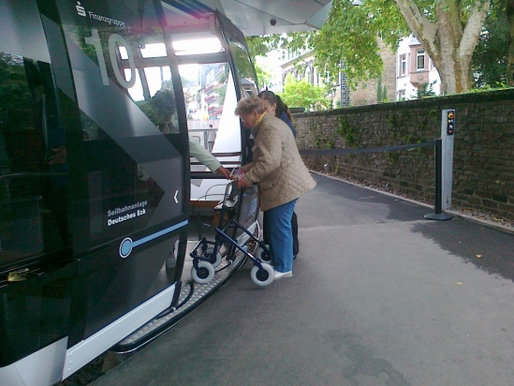 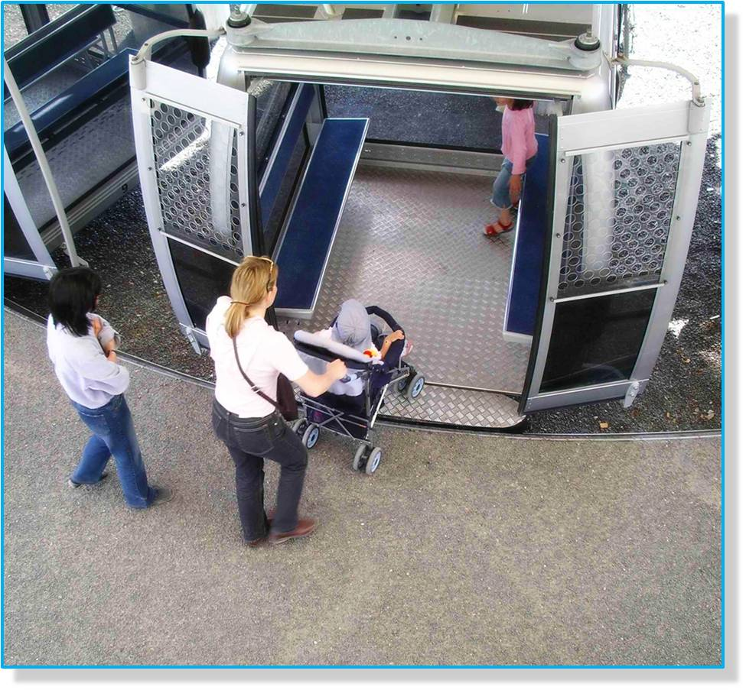

Kids and seniors alike can all enjoy riding cable transit.

Although rarely necessary, a gondola system can be brought to a complete stop by the station attendant in order to service individuals with severe mobility challenges.

1. **ARCHITECTURE**

Cable car stations are highly customizable and can be designed to blend in with surrounding buildings, integrate directly into existing structures, or complement any architectural style.

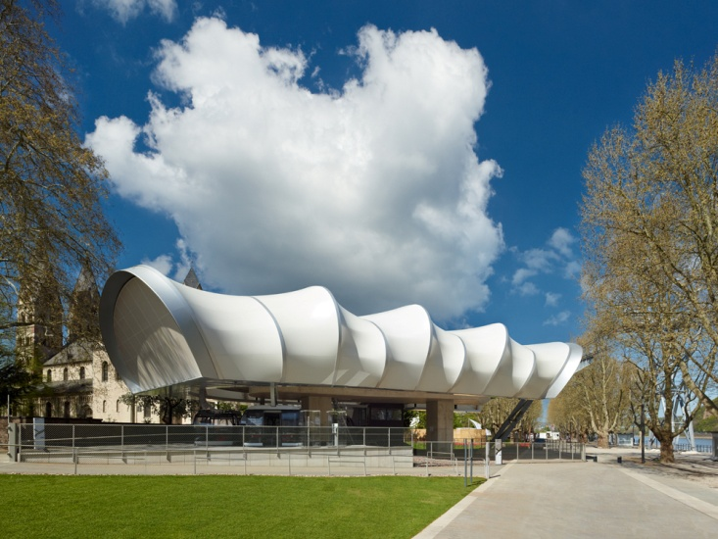

Stations can be low profile and, depending on the chosen form of cable technology, can utilize street level loading, such as in Koblenz.

1. **RECENT TRENDS**

Recently cable car systems have made a comeback. Some of the driving factors behind cable’s resurgence into the urban market include cost, speed of construction, and new advances in the technology.

This trend is not specific to any one location, culture, or economy. In the past four years, nine new systems have been built around the world — one on nearly every continent.

Many large cities such as Lagos, Montreal, Mecca, and Hamburg, in various stages of planning, designing, and constructing new cable car lines.

1. **COST COMPARISIONS**

Generally speaking, the cost of cable transit is about 1/3 to 2/3 the cost of other standard fixed link transit (all things being equal of course).

Costs provided should not be considered conclusive, but rather are approximate — offered as a general guide.

When estimating any public transit infrastructure, authorities, planners, and decision makers must consider a wide variety of variables in their local context before arriving at final values.

While the cost of cable transit infrastructure is relatively straight forward, land acquisition, civil and customization costs will factor in.

Operations and maintenance costs also differ based on country (wages); technology (number of stations and therefore attendants); and usage (major replacements are effected by usage.)

1. **ECOLOGICAL FOOTPRINT**

A ropeway is based on the principle of continuous movement. As such, it is a closed system which does not require energy to move its dead weight. Ropeways only require energy to overcome mechanical friction and to move uneven payloads on the uphill/downhill sides. This means there are no losses of braking energy from carriers travelling downhill as found, for example, in the case of buses.

Furthermore, ropeways/Cable Liners do not produce local emissions of pollutants during operation!

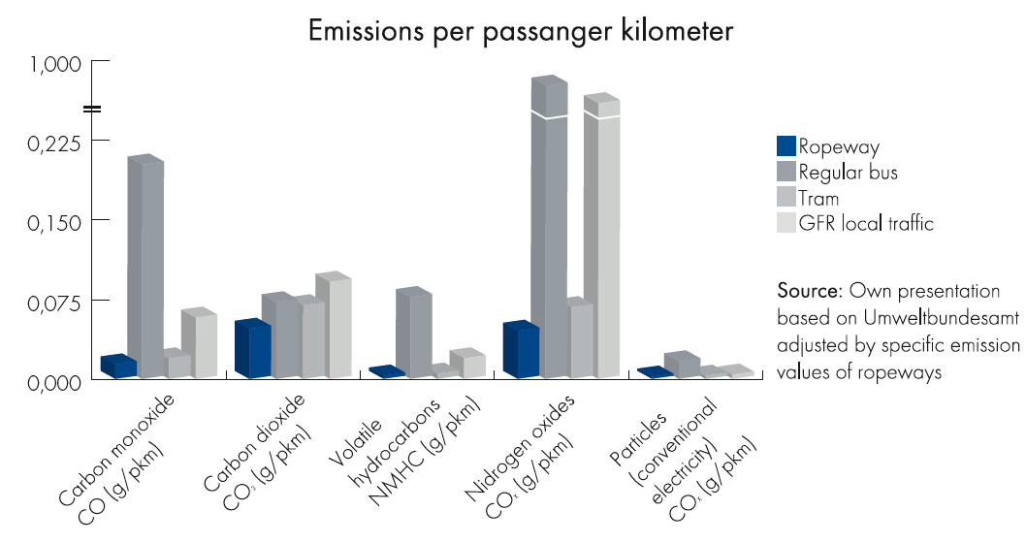

1. **OPERATIONAL EFFICIENCY**

The ropeway is a means of public transport which can be optimally linked to existing transport systems. Particularly in cases where there are barriers to overcome (such as traffic jams, buildings, waterways, roads or railway lines), ropeways can cost many times less than ground-based transport systems requiring expensive bridges or tunnels to circumvent obstacles. However, it is not only investment costs where ropeways score, but also in terms of energy consumption and personnel costs.

With very limited staffing exclusively in the stations, ropeways can carry up to 10,000 passengers an hour – the equivalent of 100 buses.

