Short-term forecasts of travel time and incident risk as tools of proactive traffic management

Satu Innamaa and Eetu Pilli-Sihvola

VTT Technical Research Centre of Finland

# Introduction

In road network management, taking action before traffic conditions become congested is often more effective than reacting as problems occur. For this proactive traffic management to work there must be enough information on the status of traffic flow (e.g. average speeds, travel times), including short-term forecasts of traffic conditions.

The Finnish Transport Agency has been searching for a method that would give a situation-aware overall understanding of traffic on the road network at any given time in order to assist operators at Finnish traffic management centres (TMCs). The visual presentation of this information should include short-term predictions of traffic developments.

In view of the above, it was essential that the approach be practical, the output of sufficient quality, and information on the quality of forecasts easily accessible. Specifically, a key element in proactive traffic management is the prediction of travel time in different traffic and road weather circumstances. In addition, ways to monitor and identify risk factors on the road network should be developed in order to anticipate the potential emergence of accidents and other traffic incidents and predict their likely consequences.

The purpose of the paper is to describe methods for creating an accurate overall understanding of the current status of the transport system and predicting changes in traffic conditions. Here the most important task is travel time prediction. We also discuss the need to find methods for assessing incident risk. The full results of the work are provided in a research report by Innamaa et al. (2013).

# Travel time prediction

As mentioned above, travel time prediction is the most important task in understanding and predicting transport system status. For short-term prediction of travel time a known Danish best practice was piloted in the Helsinki metropolitan area in Finland.

The Danish Road Directorate uses the dynRP model to predict travel times automatically in real time (Danish Road Directorate, no date). The model is based on two curves: free flow speed and historic average. Through interpolation and extrapolation, the travel time is predicted by assuming the ratio of measured loop detector travel time to the historic average to be constant. Historic averages are updated automatically daily using e.g. the past 6 months of data. All five day types are treated separately: Monday, Tuesday / Wednesday / Thursday, Friday, Saturday, and Sunday / Holiday.

In Denmark, the forecast is given for the next 15 and 30 minutes. Historic averages are used only in normal traffic conditions. The normality of a condition is determined based on threshold values. If the traffic condition is considered abnormal, the last measured value is used as the best forecast.

The dynRP travel time prediction model was piloted on Ring I in the Helsinki metropolitan area, which is one of the most congested roads in Finland. The pilot was conducted on two links: Konala–Pakila (eastbound, free flow travel time approximately 330 seconds) and Pukinmäki–Konala (westbound, free flow travel time approximately 180 seconds).

As traffic monitoring on Ring I is based on a travel time camera system, dynRP needed to be slightly modified. The piloted version of the model was based on direct travel time measurements monitored using the existing licence plate recognition (LPR) camera system. As travel time observations include outliers – due both to failures in the monitoring system and to vehicles stopping on the way, e.g. at a supermarket – the median seemed to be a more suitable indicator than the average value. Data from 2011 was used in creating the model and that from 2012 was used in testing it.

The travel time data outliers resulted in small numbers of travel time observations also creating outliers to the median values. It was thus decided to base the median on at least five observations before inclusion in calculations or testing of the model. The proportion of time with a sufficient number of observations was 45.4–46.3% on test links.

The model was built for the year 2011 using all travel time medians based on at least five observations (*Figure 1*). The model was calculated as the median value of median travel times measured for that particular moment in time (1 minute slot) and weekday. In the models, travel time was considered equal to free flow travel time if fewer than five medians were available for the corresponding minute and day.

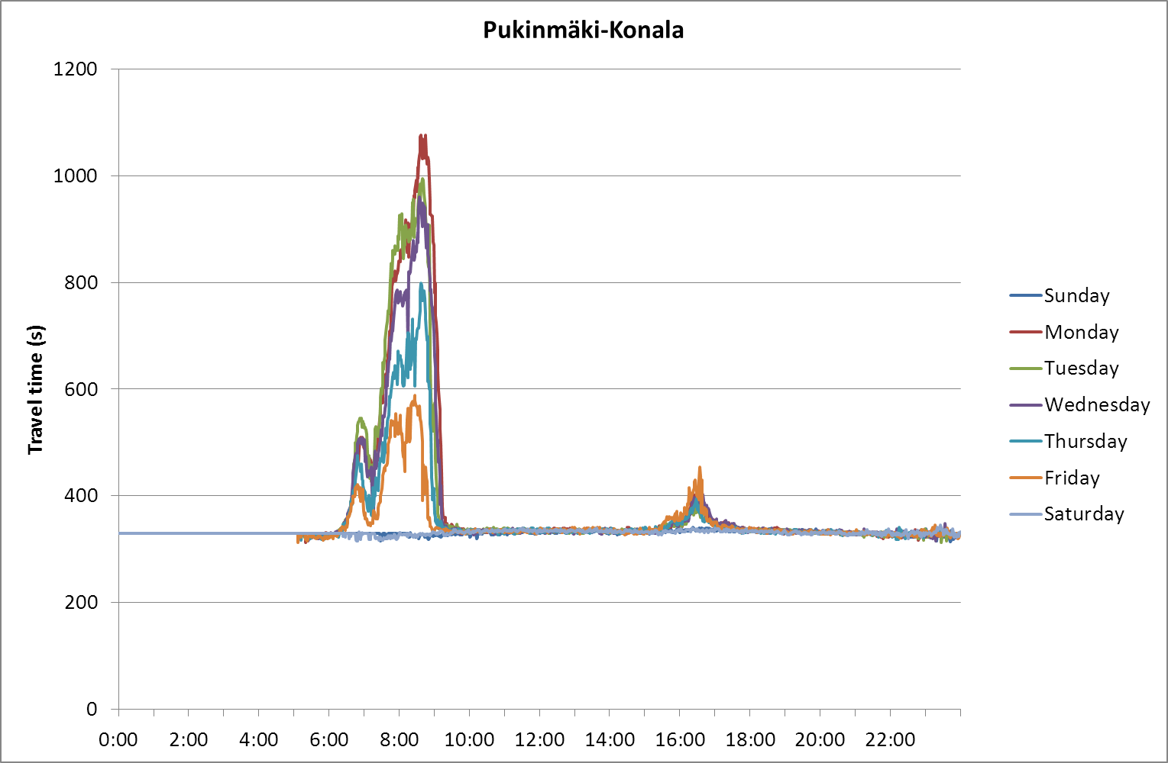

*Figure 1. Historic models of 5-minute medians (min. 5 observations) determined for each minute and weekday (free flow travel time if less than 5 medians for the corresponding minute and day)*

In Denmark, Tuesday, Wednesday and Thursday were combined into one average. However, as all weekdays seemed to differ on Ring I in Finland they were all kept separate.

The model was tested with data from 2012. Only values based on at least five observations were included in the test dataset and were not measured at night (00­–05). The forecast was calculated as a product of the historic median travel time of the current weekday for the next 15 minutes and the ratio between the current travel time and the corresponding historic median:

$${TT}_{+15}=\frac{{TT}_{00}}{{\overline{TT}}_{00}}{\overline{TT}}_{+15}$$

If the measured travel time or forecast was faster than the free flow speed (330/180 s), the value was replaced with the free flow speed for the error calculation. As travel times corresponding to speeds above the posted limit are not shown to the public, it is of no interest to see how much the estimate differed from the true value in those conditions.

The results were calculated for moments at which measured values corresponding to the period of the predicted outcome existed. The average absolute value of the relative error was 3.2–4.1% for all traffic conditions and 13.3–15.2% for congested conditions, determined as traffic for which the travel time has risen to at least 10% above the free flow median (Table 1). As the proportion of congestion was rather small, the overall performance of the model was satisfactory (82.0–87.2% of the time the error was <5% and 96.5–96.9% of the time <20%), but clearly poorer in congested conditions (30.4–30.5% and 76.6–81.8%, respectively).

*Table 1. Model test results based on 2012 data. Traffic was considered congested if measured travel time for the prediction moment was at least 10% above the free flow median.*

|  |  |  |  |  |
| --- | --- | --- | --- | --- |
|  | **Pukinmäki–Konala** | | **Konala–Pakila** | |
| **All** | **Congestion** | **All** | **Congestion** |
| Average absolute value of relative error | 4.1% | 13.3% | 3.2% | 15.2% |
| Proportion of time when error <5% | 82.0% | 30.4% | 87.2% | 30.5% |
| Proportion of time when error <10% | 91.9% | 55.9% | 93.6% | 52.3% |
| Proportion of time when error <20% | 96.5% | 81.8% | 96.9% | 76.6% |

The correspondence of predicted and measured outcomes as flow status classes was also studied. The results show that most of the free flowing traffic (travel time at most 10% over free flow travel time) was predicted correctly (success rate 95.6–97.2%, Table 2). In addition, most of the stopped traffic (travel time more than 90% over free flow travel time) was predicted correctly (78.7–82.0%). However, the flow status classes between them were predicted less well, with 37.6–62.9% success rate for flow with travel time 10–75% over free flow travel time. The poorest performance was for the flow status with travel time 75–90% over free flow travel time, with only 14.2–19.0% success rate. Large errors (at least two flow status classes) were most frequent for flow with travel time 25–75% or >90% over free flow travel time (11.0–13.6%). Large errors were least frequent for the two most fluent flow classes (0.7–2.7%).

*Table 2. Test results* *as correspondence of flow status classes, basic model*

|  |  |  |  |  |  |  |
| --- | --- | --- | --- | --- | --- | --- |
|  | | **Measured output, % over free flow travel time** | | | | |
| **0-10%** | **10-25%** | **25-75%** | **75-90%** | **>90%** |
| **Konala-Pakila link** | **Correct class** | 97.2% | 43.6% | 47.2% | 14.2% | 78.7% |
| **False by more than one class** | 0.7% | 2.7% | 13.6% | 8.5% | 11.9% |
| **Pukinmäki-Konala link** | **Correct class** | 95.6% | 37.6% | 62.9% | 19.0% | 82.0% |
| **False by more than one class** | 1.3% | 2.7% | 13.1% | 4.1% | 11.0% |

Classes where the measured travel time was 10–25% and 75–90% of the free flow travel time always seemed to perform the worst — probably because they exist mainly as "passing" classes between more stationary ones. Congestion seldom continues (time-wise) in these classes but changes either for the better or worse, which is why they are hard to predict. This could also be typical of these road sections.

The success of using the last measured value as a forecast was used for comparison with the prediction model (Tables 3 and 4). On the Konala–Pakila link, the average relative value of relative error was equal to or almost equal to the prediction model. On the Pukinmäki–Konala link, the prediction model performed better than use of the last measurement (e.g. 13.3% vs. 17.7% average absolute value of relative error in congestion). Looking at the correspondence of flow status classes, the proportion of correct classes was lower with use of the last measurement for all classes, except for the free flowing class where the performance was very similar. In addition, the proportion of large errors was greater with use of the last measurement in these traffic conditions.

*Table 3. Results when the last measurement was used as a forecast. Traffic was considered congested if the measured travel time for the prediction moment was at least 10% above the free flow median.*

|  |  |  |  |  |
| --- | --- | --- | --- | --- |
|  | **Pukinmäki-Konala** | | **Konala-Pakila** | |
| **All** | **Congestion** | **All** | **Congestion** |
| Average absolute value of relative error | 4.8% | 17.7% | 3.2% | 15.6% |
| Proportion of time when error <5% | 81.1% | 20.1% | 87.1% | 28.7% |
| Proportion of time when error <10% | 89.9% | 41.1% | 93.5% | 51.2% |
| Proportion of time when error <20% | 94.7% | 71.0% | 96.8% | 75.8% |

*Table 4. Test results when using the last measurement as a forecast, by flow status class.*

|  |  |  |  |  |  |  |
| --- | --- | --- | --- | --- | --- | --- |
|  | | **Measured output, % over free flow travel time** | | | | |
| **0-10%** | **10-25%** | **25-75%** | **75-90%** | **>90%** |
| **Konala-Pakila link** | **Correct class** | 96.9% | 40.1% | 43.0% | 9.0% | 77.2% |
| **False by more than one class** | 0.7% | 2.6% | 22.6% | 11.8% | 13.8% |
| **Pukinmäki-Konala link** | **Correct class** | 96.0% | 25.6% | 41.2% | 14.6% | 76.3% |
| **False by more than one class** | 1.6% | 4.3% | 29.8% | 7.7% | 15.4% |

In the results above, the forecast was calculated from the historic median curve independent of the ratio between the current state and the curve value. However, the Danish Road Directorate suggests using a threshold above which the last measurement is used instead of the forecast. Such a threshold value was sought by studying the proportion of time when the forecast would have been a more accurate choice as a function of the ratio between current state and historic curve. Nevertheless, based on the results the historic median based forecast was more reliable than the latest measurement, even if the difference between the latest measurement and the historic median was 100%. Therefore it is recommended always to extrapolate the forecast from the historic value.

If a forecast accuracy of 15 minutes is not satisfactory, shorter prediction periods could be a solution. We tested what the accuracy of forecasts would be if the prediction period were shorter: 10, 5 or 1 minute(s). The same principles were applied as in the 15-minute model.

The result of the basic model for different prediction period lengths was clear: it improved with a shorter prediction period, as seen in a smaller average error, smaller proportion of large errors, bigger proportion of correct forecasts and smaller proportion of forecasts false by more than one class. However, this is also true with the last measurement used as the forecast. Thus the suitability of the models is not certain despite the better performance. Consequently, the same performance indicators were calculated for 10-minute, 5-minute and 1-minute prediction periods assuming that the forecast would have been equal to the latest measurement.

For the 15-minute model, the forecast based on historic median curve outperformed the last measurement. For shorter prediction periods this was not the case. For the Konala–Pakila link, the last measurement was more accurate than the historic median-based one for all the prediction periods. The same applied to the 1-minute prediction period on the Pukinmäki–Konala link. Thus the use of a historic median-based forecast can only be recommended for a 15-minute period.

# Incident risk assessment

Travel time prediction models like dynRP or its variant above work better the closer the traffic situation is to normal. Other more sophisticated models might be more flexible in the specific traffic environment where they perform well. Nevertheless, most (if not all) travel time prediction models are incapable of predicting an incident taking place or what kind of consequences it will have. Therefore, as incidents are daily occurrences for road operators, the use of a travel time prediction model does not solve the problem of only being able to manage incidents reactively. If proactive incident management – i.e. incident risk management – is sought, some practices are needed for real-time incident risk assessment.

The extant literature did not contain models for assessing incident risk itself. However, models were found for estimating incident duration and risk of secondary incidents, and for traffic flow and travel time prediction under incident conditions.

A method developed by Khattak et al. (2012) analyses traffic incidents and includes an online tool (iMiT, incident Management integration Tool) that could dynamically predict the duration of incidents, occurrence of secondary incidents and associated incident delays. The authors of the method assessed that such a tool could be used in TMCs to help support decision-making. The relative prediction error was found to be relatively low (37–47%) for incidents of average durations (10–30 minutes).

Vlahogianni et al. (2012) introduced a neural network model approach to extracting useful information on variables associated with the likelihood of secondary accidents. Traffic and weather conditions at the site of a primary incident were examined. To detect secondary incidents, a dynamic threshold methodology was used that considers real-time traffic information from loop detectors. The results suggest that traffic speed, duration of the primary accident, hourly volume, rainfall intensity, and the number of vehicles involved in the primary accident are the top five factors associated with secondary accident likelihood.

Kamga et al. (2011) examined the distribution of travel time of origin–destination pairs on a transportation network under incident conditions using a transportation simulation dynamic traffic assignment (DTA) model. In the model, an incident on a transportation network was executed first under normal conditions, then under incident conditions without traveller information, and finally under incident conditions assuming that users had perfect knowledge of the incident conditions and could select paths to avoid the incident location. The results suggest that incidents have a different impact on different origin-destination pairs. They confirm that an effective traveller information system has the potential to ease the impacts of incident conditions throughout the transportation network. However, the use of information may be detrimental to some origin-destination pairs while benefiting others.

An alternative approach to using mathematical models in estimating incident risk is to utilise long-term traffic operator expertise and best practices developed based on this expertise. The Rijkswaterstaat Traffic Management Centre (RWS TMC) in the Netherlands has many useful best practices related to incident risk assessment. They take a long-term approach aiming to ensure that traffic operators are aware of the areas that are incident-prone and that incident risk is reduced.

RWS TMC carries out long-term incident risk assessment by creating annual and weekly forecasts (van den Berg and van Wijngaarden, 2013). At an annual level, an area-specific list of road works and other major events known to affect traffic is maintained for the following year. This long-term forecast or situational picture is updated monthly and used for traffic management and planning of road works as follows: (1) Two road works are performed in the same direction of a certain road section simultaneously rather than in sequence. (2) Road works are not performed on an alternative route or detour around other road work.

Every week, the items in the annual forecast are checked in the RWS TMC. The weather forecast and other issues that potentially affect traffic are listed together with their estimated effects to evaluate how best to increase traffic fluency. This is done in a weekly meeting with traffic operators, traffic engineers, traffic inspectors, and project managers responsible for road works to combine data and knowledge. The weekly forecast is aimed at highlighting which parts of the road network need special attention at the TMC and to provide sufficient time to code appropriate messages to variable message signs. (van den Berg and van Wijngaarden, 2013)

On a daily basis, traffic situation forecasts (maps) are prepared twice a day, morning and evening. The same week of the previous year serves as the forecast adjusted for potential exceptional conditions to represent the average traffic situation. (van den Berg and van Wijngaarden, 2013)

# Discussion

In our study, the DynRP travel time prediction model developed and applied by the Danish Road Directorate was considered the most promising and worth piloting. A slightly modified version of the model, based on median values of direct travel time measurements, was piloted on Ring I of the Helsinki Metropolitan Area. It included annual historic median values for all minutes of all weekdays separately. The forecast was interpolated or extrapolated based on the latest measurement and the historic median curve.

The main results show that a 15-minute prediction model gives better travel time estimates than using the latest measurement alone, especially in congested conditions. Specifically, the model predicted the travel time correctly 77–82% of the time in congested conditions if the forecast was considered correct when the error was at most 20%. The corresponding proportion was 71–76% with the latest measurement. The model did not fulfil the threshold of keeping maximum errors between 10% and 25% that was prevalent in the literature (Innamaa 2009). Therefore the use of this forecast may not be beneficial. Nevertheless, if decisions must be made proactively, the forecast would lead to better decisions more often than just using the latest measurement. Use of the model can therefore be recommended.

In further examination, shorter-than-15-minute prediction models provided more accurate estimates than the 15-minute model. However, with the shorter prediction period length the latest measurement served better as an estimate, and the difference from the prediction model was small if any, or even negative. Therefore, the use of these shorter-term models cannot be recommended. If shorter-term prediction is needed, the use of the latest measurement as the forecast is recommended.

The dynRP model has a 13–15% average error in congested conditions. This is slightly higher than the best models used or tested to date. However, a clear benefit of the dynRP model is that it can be fully automated without the need for neural network estimation or other special methods or manual work. If more accuracy is desired, a self-adapting model should be implemented. This would need setting up manually for each link, but there is less need for manual updating as the model adapts itself. This has been successfully piloted on Ring I (Innamaa 2009). The model ran for years at the traffic management centre of the Finnish Transport Agency.

On road sections where the annual median is equal to the free flow travel time, the forecast would in practice be equal to the latest measurement, even if a historic median-based forecast were used. Thus, the decision concerns only roads where the travel time increases frequently.

The Rijkswaterstaat Traffic Management Centre had several procedures that can be considered best practice in incident risk assessment and management. It is recommended that a procedure be set up to systematically collect and use information on events (e.g. sports events, music festivals, road works) that affect traffic. Once a month the annual traffic forecast should be updated indicating the timing and location of such events and their foreseen impact on local traffic. These annual forecasts should be studied in a weekly meeting to identify abnormalities of traffic during the coming week and to find solutions for (proactively) operating the traffic in such conditions. In the meetings, the success of the previous week’s operation should be evaluated for future improvement. The annual traffic forecast can also be used in planning the timing of road works.

# Acknowledgements

We would like to thank the Finnish Transport Agency for providing us with an interesting topic to study and for funding the research. We would also like to thank the Danish Road Directorate and the Dutch Rijkswaterstaat for providing us information on their best practices.

# References

van den Berg JM, van Wijngaarden B (2013). Interview of operational traffic team leader Jan Maarten van den Berg and road office leader Bart van Wijngaarden of Rijkswaterstaat TMC in Utrecht, the Netherlands. February 5, 2013.

Danish Road Directorate (no date). dynRP – rejsetidsprognose. Notes. 5 p.

Innamaa S (2009). Short-term prediction of traffic flow status for online driver information. Doctoral dissertation. VTT Publication 708, VTT Technical Research Centre of Finland, Espoo. 79 + 90 p.

Innamaa, S., Pilli-Sihvola, E. and Norros, I. (2013). Travel time and incident risk assessment. Research Reports of the Finnish Transport Agency 31/2013 (http://www2.liikennevirasto.fi/julkaisut/pdf3/lts_2013-31_travel_time_web.pdf). Finnish Transport Agency, Helsinki. 92 p.

Kamga CN, Mouskos KC, Paaswell RE (2011). A methodology to estimate travel time using dynamic traffic assignment (DTA) under incident conditions. Transportation Research Part C. 2011;19:1215-1224.

Khattak A, Wang X, Zhang H (2012). Incident management integration tool: dynamically predicting incident durations, secondary incident occurrence and incident delays. IET INTELLIGENT TRANSPORT SYSTEMS. 2012;6:204–214.

Vlahogianni E, Karlaftis M, Orfanou F (2012). Modeling the Effects of Weather and Traffic on the Risk of Secondary Incidents. JOURNAL OF INTELLIGENT TRANSPORTATION SYSTEMS. 2012;16:109–117.